PLAMEDI EVENTS PLAN
Plamedi events plan ni inzu ibafasha kuba heza, mugakorera heza ndetse no kugira ibirori byiza mugasabana n’incuti n’abavandimwe . Ibikorwa byayo bigera hirya no hino mu gihugu ariko icyicaro cyayo cyibarizwa mu mujyi wa Kigali.
Plamedi Events Plans itanga izihe service?
- Gutegura ibirori bitandukanye
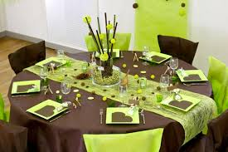
Muri ibyo birori ndetse n’imihango itandukanye harimo:
- Ubukwe (Wedding ceremony)
- Amasabukuru (Anniversary)
- Inama (Meetings)
- Ibiriyo (Mourning)
Plamedi Events Plans ibafasha mu buryo bwo gutegura ibyo birori cyangwa iyo mihango, mu gushaka abakozi babafasha muri iyo mirimo ndetse no gutegura aho bizabera.

- Kurimbisha inzu zo kubamo ndetse ni izo gukoreramo
Plamedi Events Plans ibafasha kurimbisha inzu mutuyemo cyangwa se mukoreramo ndetse niz’ubucuruzi bitewe nuko zubatse ndetse nibyo muzakoreramo.
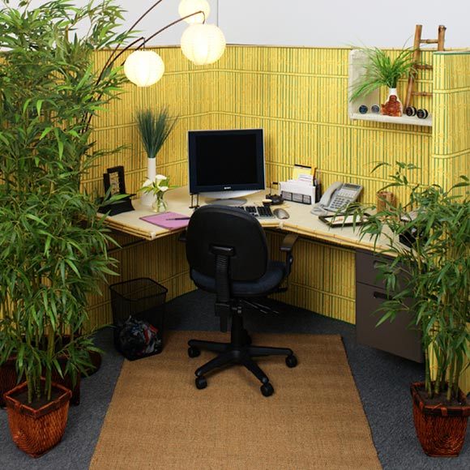
- Kurimbisha ubusitani(Garden)
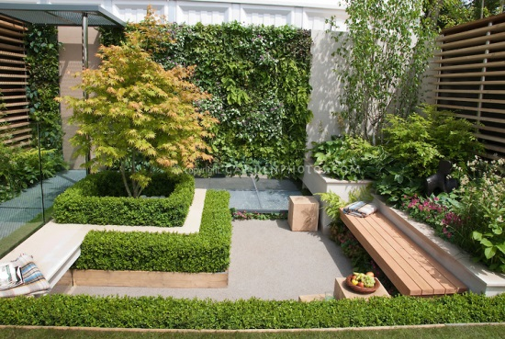
Plamedi Events Plans ihanga ubusitani bushya ndetse ikanatunganya ubusanzwe buhanze.

Ubushishozi, ubushake ndetse n’ubushobozi nibyo tugenderaho!!!!

