India orange and rose tea
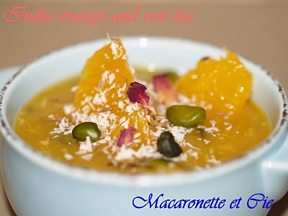
Ingredients:
4 oranges
350 ml orange juice
1 lemon juice
1 tablespoon cornflour
1 tablespoon shredded coconut
1 teablespoons rose tea (or jasmine tea)
1 teaspoons cumin seeds
1 or 2 tablespoons blanched pistachious
1 cinnamon stick
2 tablespoons suggar (optional: there is no suggar in the original recipe)

Peel totally the orange skin and take only the orange pulp
Divide among dessert cups.
Put the orange and lemon juice with the suggar into a saucepan
and bring to simmer.
Add the cornflour to the pan and stir until it thicken like a syrup.
Take off the heat and add the shredded coconut,rose tea,cumin seeds,cinnamon stick and blanched pistachious (except some of of them which should be kept for decorating)
Leave to cool.
Divide the mixture among dessert cups contaning the orange peels.
Place into the fridge for a couple of hours, until set.
Serve it fresh with little cakes.
Source : Macaronette et Cie (http://totchie.canalblog.com)

