**Commandes armes taiji quan**

**DRAGON SPORTS**

**37 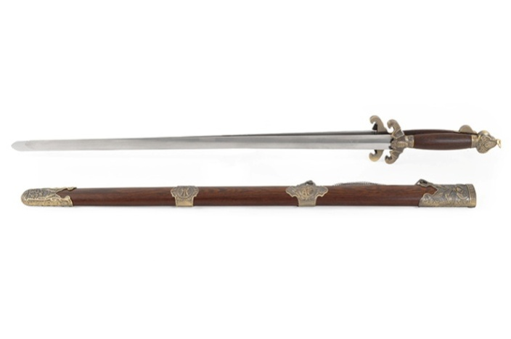 99,00€**

**38 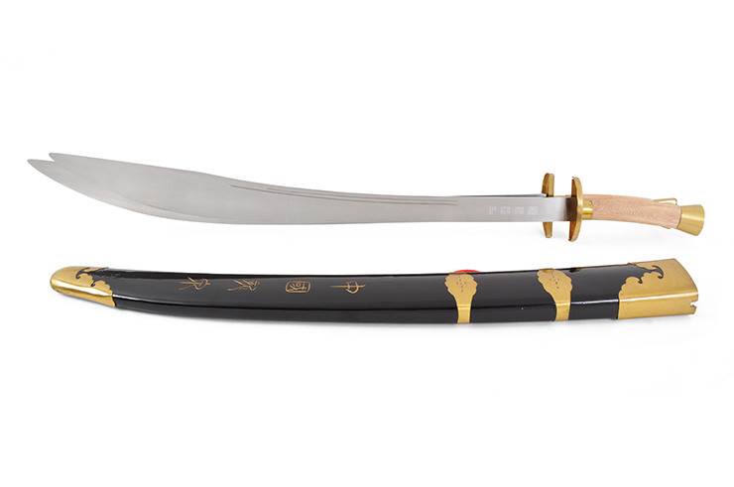 109,00 €**

**39 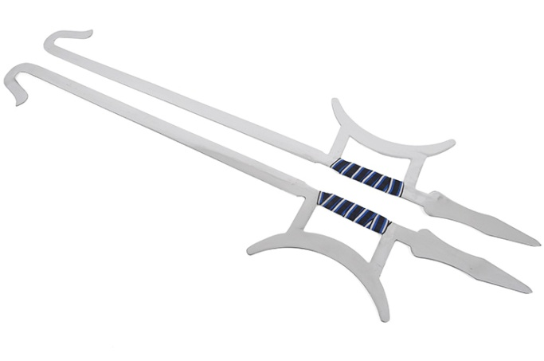 49,00€**

**40 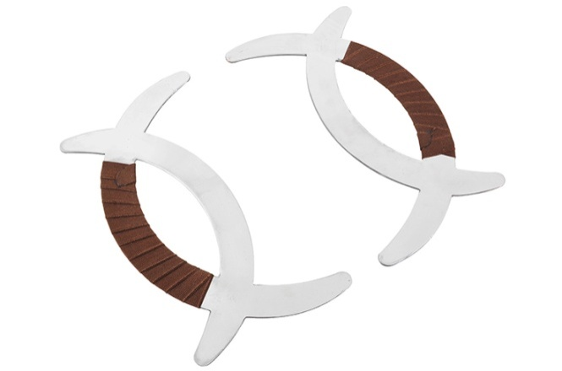 29,00€**

**41 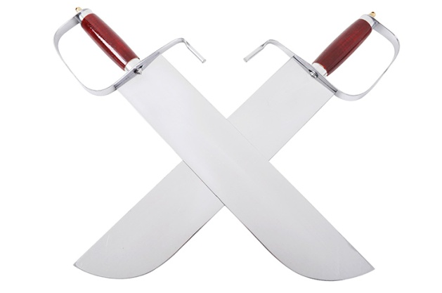 29,00€**

**42 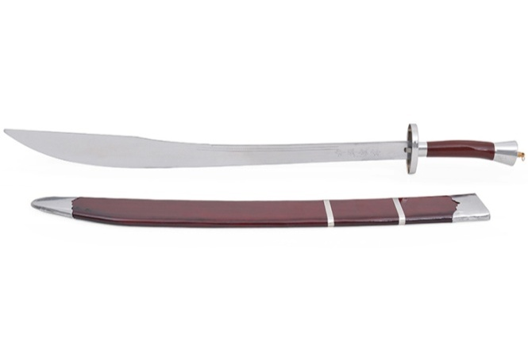 39,00€**

**43 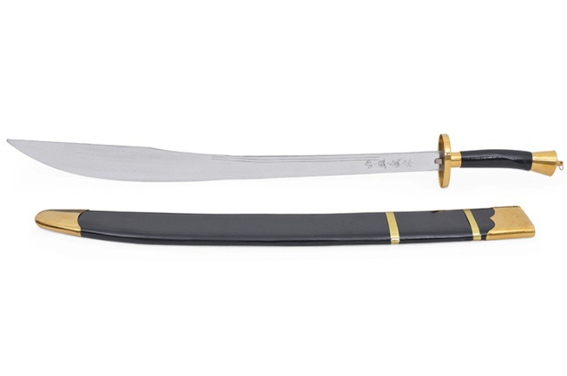 45,00€**

**44 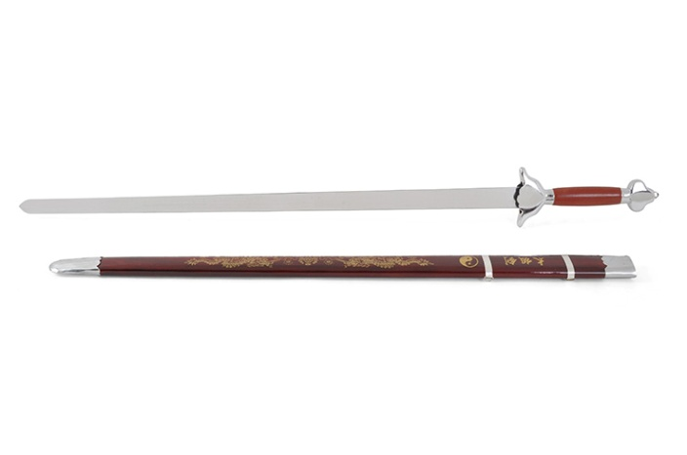 39,00€**

**45 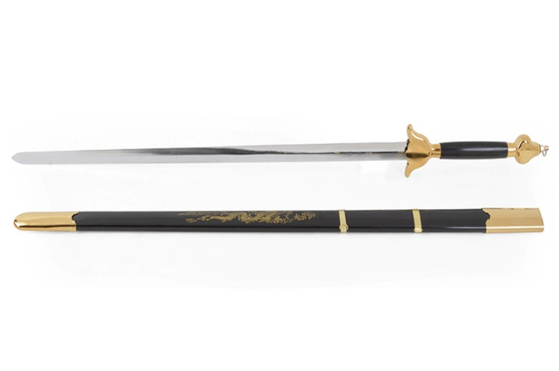 45,00€**

**46 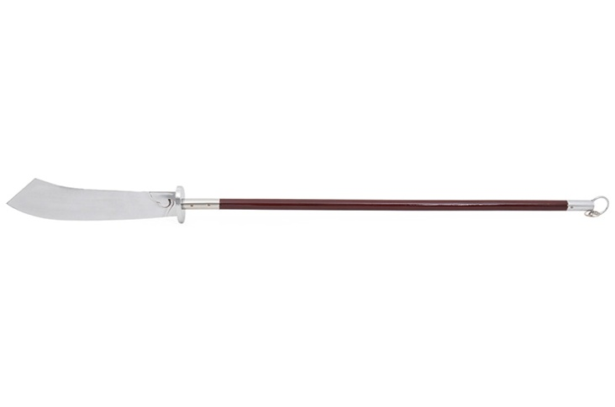 49,00€**

**47 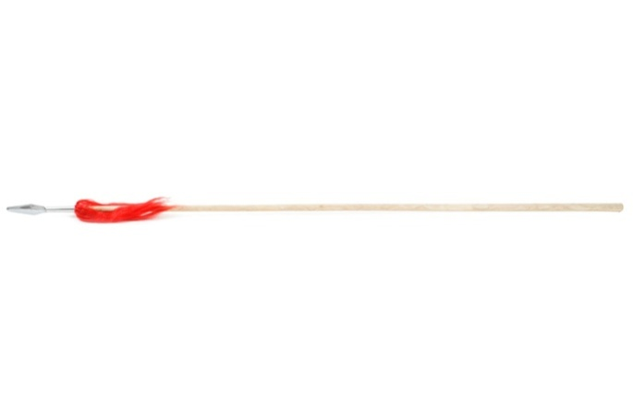 22,00€**

**48 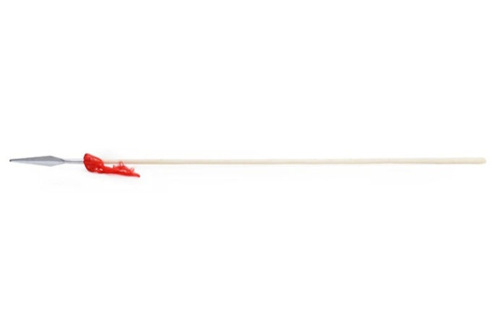 35,00€**

**49  19,00€**

**50 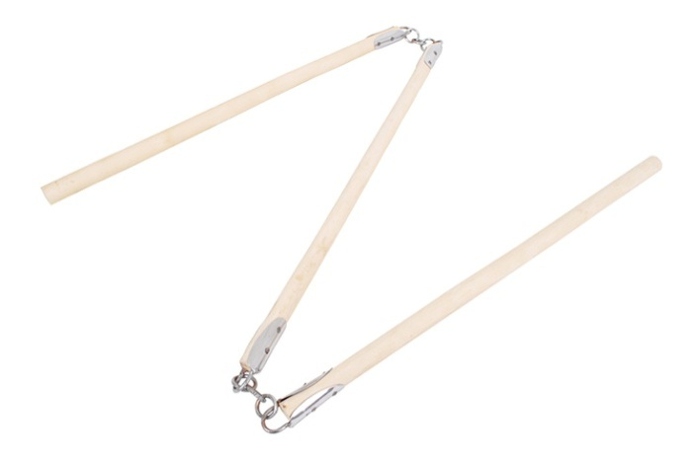 19,00€**

**51 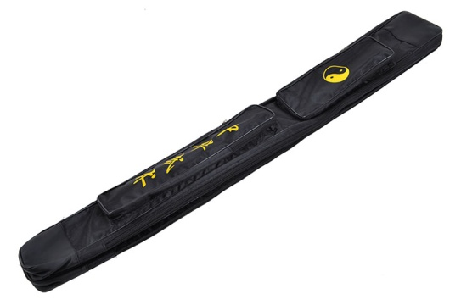 19,00€**

**52 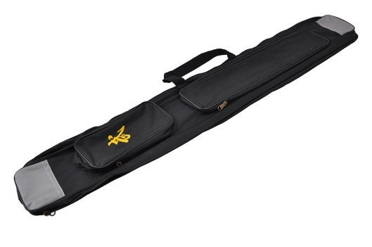 25,00€**

**53 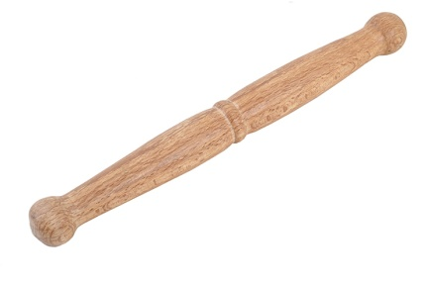12,00€**

**54 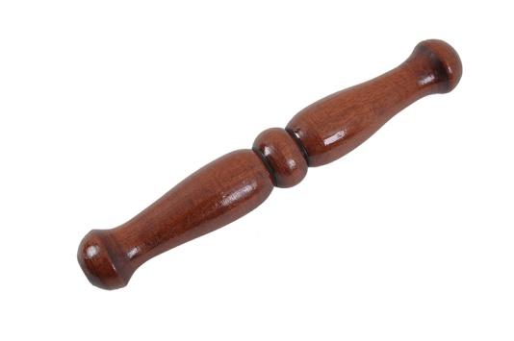 25,00€**

**55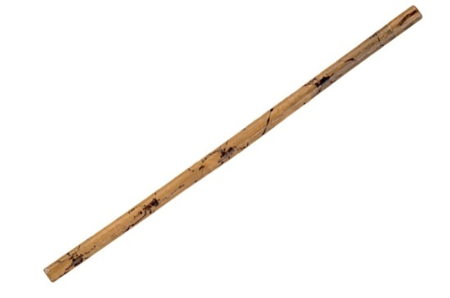 8,90€ 56** 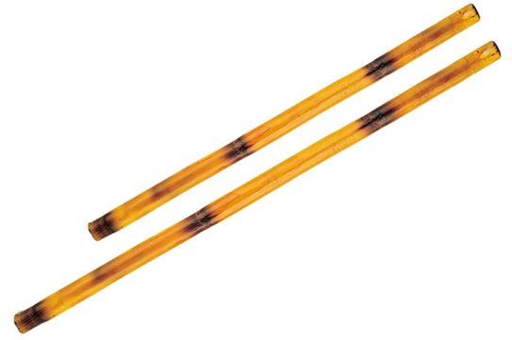

**57 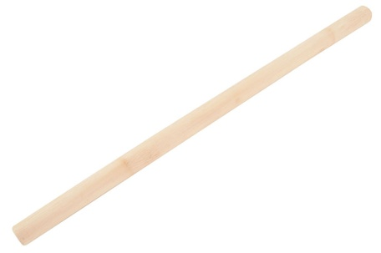 14,00€ 58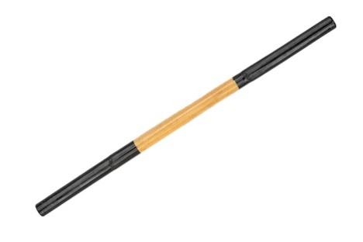15,90€**

**59 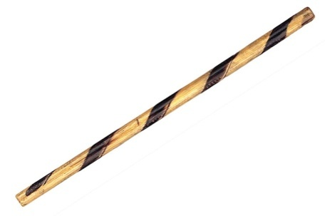 17,90€ 60** 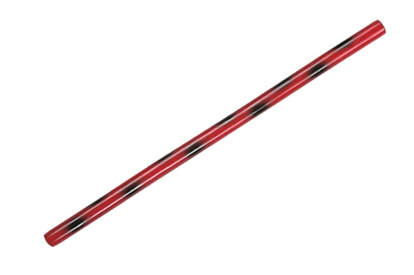

**61 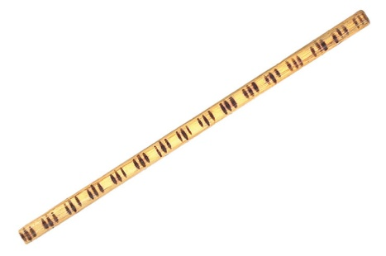 19,90 €**

**62 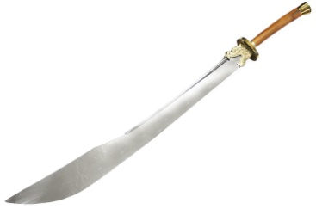 149,00€**

|  |  |  |  |  |
| --- | --- | --- | --- | --- |
| **NOM** | **PRENOM** | **COMMANDE N° ARTICLES** | **PRIX** | **TOTAL** |
|  |  |  |  |  |
|  |  |  |  |  |
|  |  |  |  |  |
|  |  |  |  |  |
|  |  |  |  |  |
|  |  |  |  |  |
|  |  |  |  |  |
|  |  |  |  |  |
|  |  |  |  |  |
|  |  |  |  |  |
|  |  |  |  |  |
|  |  |  |  |  |