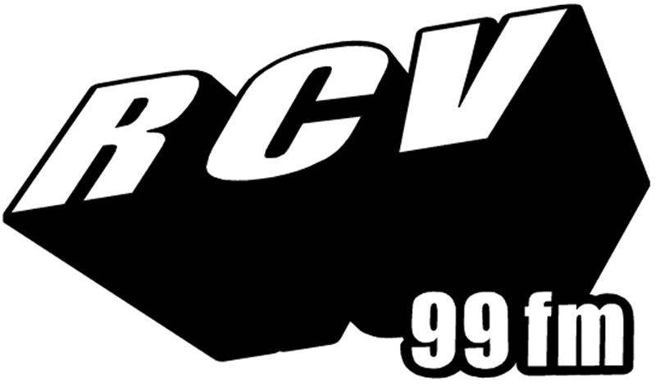
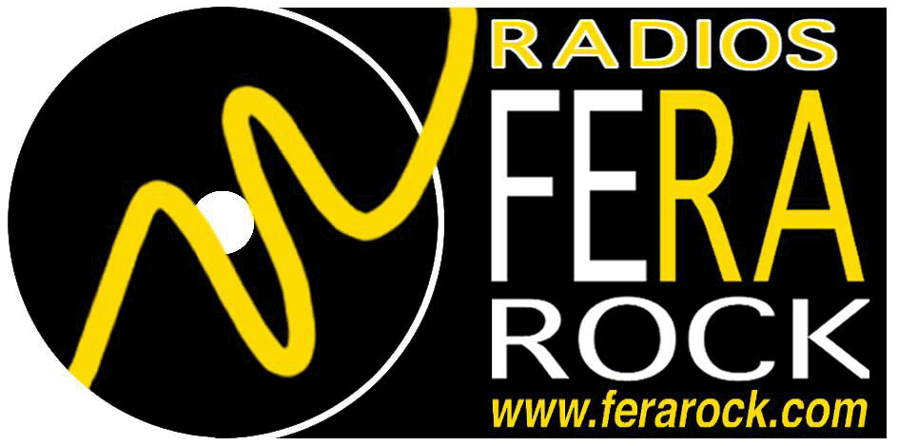
RCV 99 FM / MY FAVORITE THINGS / 41 BD VAUBAN / 59046 LILLE CEDEX / FRANCE
PHONE 00 33 6 08 32 65 11 /
EMAIL : gilles-rcv@wanadoo.fr / www.rcv-lille.com / www.myfavoritethings.canalblog.com
Dimanche 22 04 2007 de 16h à 19H
INTERPRETE | TITRE | LABEL
DIRK BLUMLEIN TERZETT | IN HEIMSHEIM DAHEIM SEIN | JAZZ’N’ARTS
THE SCIENCE FAIR | OPEN YOUR EYES | ALTRISUONI
DAVID SMITH 5TET | HALLOWEEN SONG | FRESH SOUND / ABEILLE
JEAN MICHEL PILC | THE BROOK | DREYFUS JAZZ / SONY BMG
VIENNA ART ORCHESTRA | SHE NEED NEVER REGRET | EMARCY / UNIVERSAL
VIENNA ART ORCHESTRA | THE MAGIC PENDULUM | EMARCY / UNIVERSAL
VIENNA ART ORCHESTRA | MAE WEST MEETS NICOLAUS COPERNICUS | EMARCY / UNIVERSAL
DAVID DORUZKA | EVIDENCE | CUBE METIER
RADEK KRAMPL | DEVIL’S ROCKS | CUBE METIER
JC & THE JAZZ BOPPERS | OUR DELIGHT | JAZZ-HOP INC.
JEAN-CHRISTOPHE CHOLET | FANFARE | ALTRISUONI
SEAN BERGIN’S SONG MOB | LAMBI GOLO | DATA / TOONDIST
KHOURY / MACKIE / WELCH | BLUES FOR SAM RIVERS | ENTROPY STEREO
SURNATURAL ORCHESTRA (Ciné-Concert 30 04 Casino Arras) | RABBI BOP | QUOI DE NEUF DOCTEUR
SOPHIA DOMANCICH / PENTACLE | EN EL BARRIO DE TRIANA | CRISTAL / ABEILLE
MINA AGOSSI | DO NOTHIN’ TILL YOU HEAR FROM ME | CANDID / HARMONIA MUNDI
NINA SIMONE | TIMES THEY ARE A CHANGIN | RCA VICTOR / SONY BMG
DANIEL Y. | I CAN’T SEE NOBODY | LEGACY / SONY BMG
ALBERT VAN VEENENDAAL | DANCE TO SING STRANGELY WITH | EVIL RABBIT
PLAYSTATION 6 | UNPREPARED | EVIL RABBIT
MICKEY FINN | THE RETURN OF THE GIANT SQUID | EL GALLO ROJO
TALAT | HASIDIC MONK | TZADIK / ORKHESTRA
MATT SHULMAN | SO IT GOES | JAGGO RECORDS
CHARLIE PARKER’S ALL STARS | PARKER’S MOOD | FREMEAUX / NOCTURNE
CHARLIE PARKER 4TET | BLUES FOR ALICE | FREMEAUX / NOCTURNE
BIG JOE TURNER | T.V MAMA | FREMEAUX / NOCTURNE
JIMMY WITHERSPOON | JAY’S BLUES | FREMEAUX / NOCTURNE
THE CARL SONNY LEYLAND TRIO MEETS NATHAN JAMES & BEN HERNANDEZ | DON’T KNOW WHAT YOU DID | SACRED CAT RECORDINGS

