Week 8, April 5th 2023, Land confiscation and restitution
Case Study: New Zealand
Watch this film directed and produced by two female New Zealanders and starring Maori actors. The film not only “celebrates indigenous voices” (see review below) but it deals with the burning issue of land, mainly the connection of Maori people (here the Pairama clan) to their land.
If you can’t watch the whole film, make sure you watch the first 5 minutes of the film as well as an important scene in the middle of the film ( from 0:55 min to 1:02) which represents the climax of the film.

In order to have some contextual elements and be able to discuss about the film and the land issue I suggest you read the following link: https://en.wikipedia.org/wiki/New_Zealand
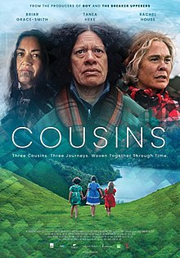
Cousins (2021) : https://www.dailymotion.com/video/x8h3ovl
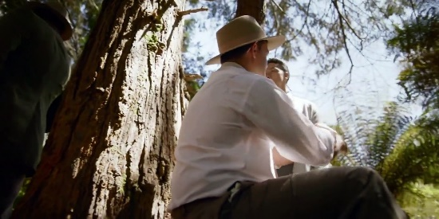 | Cousins (2021) Watch HD - Vídeo Dailymotion  Cousins (2021) Watch HD Stream English  www.dailymotion.com

Cousins, film director Ainsley Gardiner and Briar Grace-Smith. Released in 2021 based on a novel written by Patricia Grace.
Review : https://awfj.org/blog/2021/07/14/cousins-review-by-leslie-combemale/

