Les consonnes longues : le chat

## SON 8

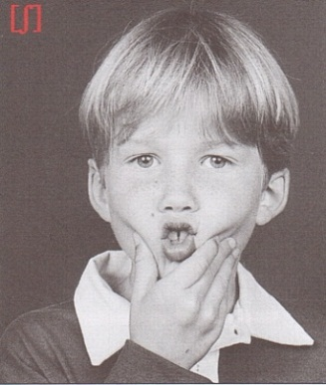

**chhhh**

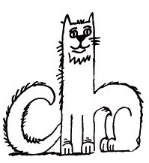

**Le chat** aime le silence. Il ne miaule pas : il chuchote.

ch ch Ch Ch



la ru**ch**e

Prends tes joues et dis ch.

🡺 🡺 🡺 

|  |  |  |
| --- | --- | --- |
| o |  |  |
| u |  |  |
| e |  |  |
| a |  | ch |
| y |  |  |
| i |  |  |
| é |  |  |

|  |  |  |
| --- | --- | --- |
|  |  | a |
|  |  | i |
|  |  | o |
| ch |  | e |
|  |  | u |
|  |  | é |
|  |  | y |

[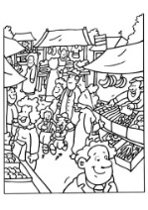](http://www.coloriage-dessin.com/coloriage_img/coloriage-marche-1232810075.jpg)[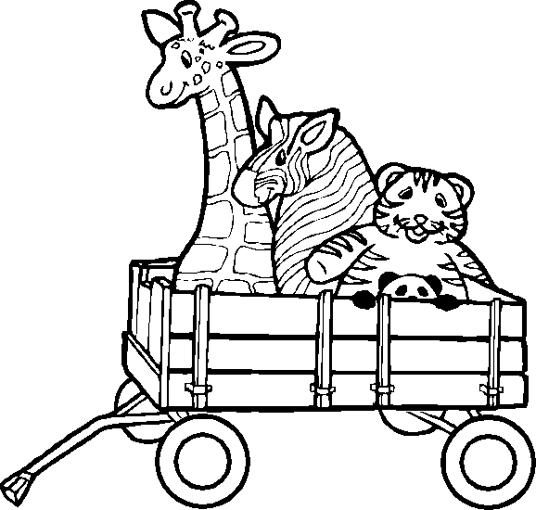](http://www.momes.net/histoiresillustrees/dino/chariot_animaux.gif)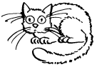[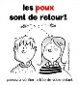](http://1.bp.blogspot.com/_jLvmG_gvlEw/TJ9d2kTd3fI/AAAAAAAAG_g/b0Kou9n_FHA/s320/affiche-poux-dessin.jpg)

Ci Cu Cy Cé Co Ce

**ch**i **ch**u **ch**y **ch**é **ch**o **ch**e