If you’re happy Song
If you’re happy, happy, happy
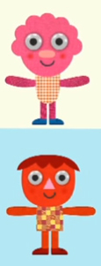
Clap your hands x2
If you’re happy, happy, happy
Clap your hands, Clap your hands
If you’re happy, happy, happy
Clap your hands

If you’re angry, angry, angry
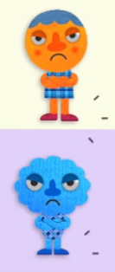
Stomp your feet x2
If you’re angry, angry, angry
Stomp your feet, Stomp your feet
If you’re angry, angry, angry
Stomp your feet

If you’re scared, scared, scared
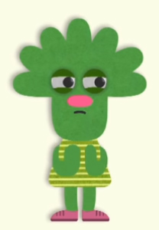
Say Oh no ! (Oh no !) x2
If you’re scared, scared, scared
Say Oh no ! Say Oh no !
If you’re scared, scared, scared
Say Oh no ! (Oh no !)

If you’re sleepy, spleey, sleepy
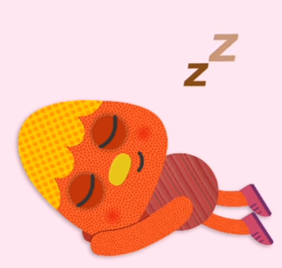
Take a nap x2
If you’re sleepy, spleey, sleepy
Take a nap, Take a nap
If you’re sleepy, spleey, sleepy
Take a nap

If you’re happy, happy, happy
Clap your hands ……….

