Sport By: Mr Seddik Mahmoud
a) - Individual sport:
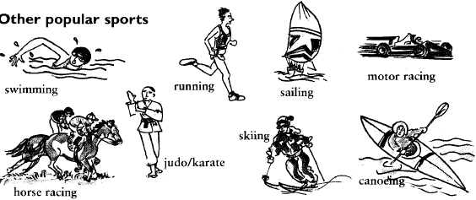
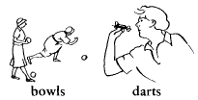
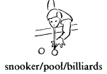
- She goes swimming - he goes skiing - they go running
For judo and karate we say: - I do judo. - She does karate

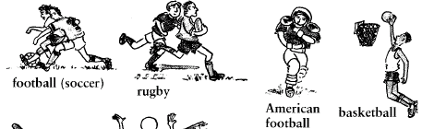
b) - Team sport:
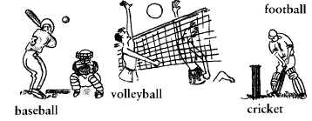

c) - People who play sport:
…er: -Footballer - golfer - cricketer - swimmer - jumper etc
Player: basketball - player, tennis- player, snooker-player, darts-player etc
…st: gymnast, canoeist, cyclist, etc

d)- Football verbs:

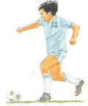
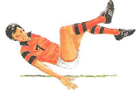
To dribble to kick to save to throw to blow the whistle to fall

e) - Athletics:
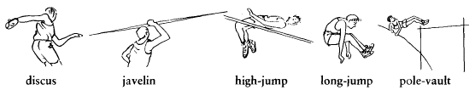
- Hicham Elgarouj is a great medium and long-distance runner. He holds the 1500 m record.
- John bolt is a good sprinter (runs 100m or 200 m). He broke the Olympic record at Beijing Olympic Games.

