Non-Projected Display Materials
- 6.2.1 Chalkboard and Whiteboard
- 6.2.2 Flannelboard and Magnetboard
- 6.2.3 Flipboard, Charts and Wall-Charts
- 6.2.4 Posters and Pictorial Materials
- 6.2.5 Realia and Models

6.2.1 Chalkboard and Whiteboard
What must you do to use the chalkboard and whiteboard effectively?
Click Yes or No for a response
a. | Write legibly and horizontally | Yes | No
b. | Hold the chalk like a pen or pencil | Yes | No
c. | Use chalks and felt-tip pens of various colours | Yes | No
d | Stand on your left-hand side to write if you are a right-handed person (and vice versa if you are a left-handed person) | Yes | No
e. | Concentrate on the centre of the board | Yes | No

6.2.2 Flannelboard and Magnetboard
Why use the Flannelboard?
- A flannelboard is simple and inexpensive to construct. It is easy to store and light to carry. It makes you more mobile as you can move it to where your students are sitting if need be.
- You can use the flannelboard to provide a wide range of language practice for your students from language skills, forms or functions to grammar items.
- Your students enjoy participating in flannelboard activities if you choose materials appropriate to their mental maturity. The flannellboard is not just a primary school medium.
- The flannelboard is a dynamic medium in that it provides a way of presenting 'mobile' situations and changes can be shown by adding or taking away figurines and flashcards.
Figurines for the Flannelboard
- Make them yourself: choose a reasonably thick cardboard to ensure durability. Cut out the figures or objects large enough to be seen by students at the back of the class. Do not have too much detail on them. Give them a clear coat of varnish to make them more lasting. Make a collection of figurines from magazines, posters, newspapers, wrapping papers, etc. Use a variety of materials: felt, woollen material, velvet, suede, blotting paper, sponge or any other material with natural adhesion.
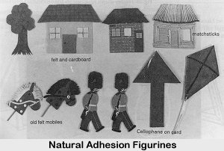
- Aim to build up sets or categories of figurines rather than try to prepare them for individual lessons or specifice language items. Examples of sets of figurines: people in general, people doing things, occupations, food, household objects, places, animals, symbols logos.
- Store figurines in stiff, clear plastic envelopes (these can be bought), each clearly labelled with the contents. You can also make your own 'filing-cabinet' from a small wooden or cardboard box.
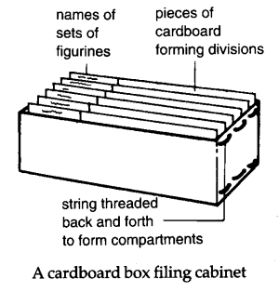

6.2.3 Flipboard, Charts and Wall-Charts
Introduction
Flipcharts, Charts and Wall-charts are versatile and useful visual aids that have been used by teachers for a long time. Let us now look in turn at each of them to see how you can use them effectively in your teaching.
Flipcharts
These consist of a number of large sheets of paper, fixed to a support bar, easel or a display board by clamming or pinning them along their top edges so that they can be flipped backwards or forwards as required. See illustration below:
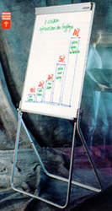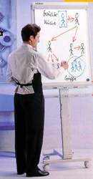
Illustration of flipcharts
Advantages of Using Flipcharts
- Simple to use
- Inexpensive
- Portable
- Need no electricity
- Effective — they help to focus your learners’ attention
- Useful for background information
- Can reveal successive bits of story
- Can record ideas from discussions and keep for future reference
Can you think of ways of using flipcharts effectively?
Jot down your ideas and compare them to the suggestions below.
Click on each of these suggestions to see its elaboration.
- Preparing your Charts
- Using the Flipchart on the spot during your presentation
- Using Flipcharts for Group Discussions
What do you think? Jot down your ideas and compare them with mine. Click on each of my ideas above to see how I have elaborated on them.
Now work through the rest of Unit 6 to learn how best you can use these teaching aids to make your teaching more effective and interesting.

Charts and Wall-Charts
Although charts and wall-charts are basically the same, they can be distinquished in two ways:
- Charts usually refer to displays on large sheets of paper or cloth that are designed to be shown to a class or group in the course of lesson. Wall-charts are displays that are pinned to a wall or bulletin board and are mainly intended for casual study outside the context of a formal lesson.
- The material on charts are usually larger and easier to read than on wall-charts as the former has to be clearly distinguishable or legible at a distance whereas the latter can be studied at close quarters.
Both charts and wall-charts have a great advantage in that they can contain far more complicated and detailed information than say, transparencies or flipcharts.
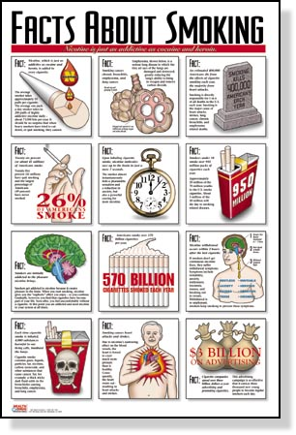
Illustration of a wall-chart
What must you consider when you plan to produce your own charts and wall-charts? Write down your suggestions and then click here to see my ideas on the matter.

6.2.4 Pictorial Materials
Introduction
Pictorial materials are so easily available yet some teachers complain that they cannot get ‘good’ pictures for teaching purposes. These teachers seem to be confused with what constitutes a ‘good’ picture. Is a picture ‘good’ only when it is big enough to be seen by a class of forty students? Is it ‘good’ only when it is colourful? Is it ‘good’ only when it represents the item you want to teach? Actually, any picture in the hands of the skilful teacher can be effectively used for teaching purposes.
What must you do to ensure that you have ‘good’ pictures available when you need to use them? Here are some suggestions:
- Build a collection of pictures – all kinds of pictures: big, small, black and white, colourful – from various sources: magazines, newspapers, books, calendars, brochures and leaflets, posters, catalogues, book jackets, those downloaded from the Internet, by writing to commercial and social organisations, even drawing your own pictures.
- Organise your collection by storing and labelling them appropriately. Large pictures should be stored separately from small pictures.
- Mount pictures that you are going to use regularly or if the mounting helps them to be shown more effectively.
- Make copies, enlarge or minimise the pictures as needed. Today’s photostating machines can easily do this work for you.
What factors must you consider when selecting a picture for a particular lesson? Jot down your ideas and compare them with the suggestions below.
- Appeal: the picture should capture the interest and imagination of your students.
- Relevance: the picture should be appropriate for the purpose of the lesson – it must contribute directly to the aim of the lesson. Don’t use a picture just because it is attractive or that your students find it fascinating.
- Recognition: The significant features of the picture should be within your students’ knowledge and cultural understanding.
- Size: If you are showing a picture to the whole class, it must be large enough to be seen clearly by all. For pair and group work, the picture can of course be smaller.
- Clarity: Avoid crowded pictures – they can confuse and distract your students. The relevant details must be clearly seen. Choose pictures with strong outlines and contrast in tone and colour to avoid ambiguity.
How can pictures be used in the language class? The following are just some possibilities. I am sure you can suggest some more.
- You can use pictures to present new grammatical and vocabulary items and avoid giving long explanations of meaning or resorting to translation.
- You can use pictures to provide meaningful practice of vocabulary and structures. These pictures can be used as cues or prompts to get your students to repeat words or structures.
- You can use pictures as stimuli to get your students to speak, read or write at the reproduction stage of language learning. The pictures can provide your students with information about objects, events or actions for them to speak, read or write about.
- You can use pictures at the set induction stage to stimulate students’ interest or to relate to students’ background knowledge.
- You can use composite pictures (usually they are large, single pictures depicting a scene in which a number of people are seen doing things) for whole-class teaching to get your students to describe the scene.
- You can use a picture series (a number of related composite pictures linked to form a series or sequence) to get your students to tell a story or a sequence of events. The picture series can be used as they are, on one sheet, or they can be cut up into individual frames; the latter allows for more varied use in the classroom.
- You can use picture flash cards to present a single concept, such as an object or an action. However, picture flash cards are best used to revise or practise previously taught language rather than for the presentation of new items.

6.2.5 Realia and Models
What is Realia?
In the context of the ESL classroom, realia can be defined as a real object which:
- has a purpose outside the ESL classroom and
- can be brought into the classroom
Realia can be in the form of:
- Written text or print taken from newspapers, magazines, books, the Internet which have not been written for the purpose of second language teaching and learning.
- Audio-visual materials not produced for the purpose of second language teaching and learning.
- Non-linguistic such as stones, leaves, food products, clothes, etc.
Why use Realia?
- Connects your students to the world outside the classroom
- Makes language learning more relevant and meaningful
- Prepares your students for post-classroom experience
- Motivates your students to investigate and use L2 outside the classroom
What problems might you face when you bring linguistic realia into the classroom?
- Complexity of the text (oral or written): you might find that the grammar, vocabulary or text structure too complex for your students’ level of ability
- Your students might have problems understanding a native speaker’s pronounciation because of his or her dialect, hesitations or rapid speech
- Your students might have problems understanding the cultural references being made in terms of geography, history, humour, philosophy, customs and social issues
There are certain principles that you must keep in mind when using realia in the classroom.
- General
  - Tell your students that it is "real"
  - Choose realia that is relevant and interesting
  - Provide the relevant cultural background beforehand
  - Make connections to realia in your students’ own culture
- Linguistic Realia
  - Be aware that the text (print or audio-visual) may be too difficult for your L2 students to understand most or all of it
  - When there are vocabulary problems, you can do or more of the following:
    - Introduce the words in advance
    - Focus on other things besides the vocabulary
    - Focus on the key words

  - For lower ability students:
    - Choose the text very carefully
    - Focus on specific aspects of the text

  - Use dramatic techniques to help clarify written text or audio-visual materials
  - For print materials, make sure you have enough copies
  - For audio-visual materials, make sure the recording is clear; that you preview the material beforehand; that you have the proper equipment and know how to use it
- Non-Linguistic Realia
  - Have a clear idea of your linguistic purpose
  - Preteach relevant vocabulary and grammatical points
Models
- are objects that duplicate as accurately as possible the real objects. Sometimes they are smaller versions of the real objects.
- Some models can be commercially bought for teaching purposes and some can teacher-made.
- Some useful models that you might consider having in the language classroom: model telephone, globe, clock
What are Models good for?
- Demonstrating
- Making an impact
- Explaining a process
- Making a topic interesting
Consider the following when you use models in your lesson:
- Ensure that the model will work
- make sure that it is big enough for your students to see
- If you pass the model around in the class, make sure that your students are given enough time to examine the model.
© Copyright 1999-2001 Department of Language Education,
Universiti Malaya Kuala Lumpur
Send comments about this site to The Webmaster

