|  |  |  |  |  |  |  |  |
| --- | --- | --- | --- | --- | --- | --- | --- |
| Ma semaine | | | | | | | |
|  | lundi | mardi | mercredi | jeudi | vendredi | samedi | dimanche |
| Matin | http://www.coloriage-dessin.com/coloriage_img/coloriage-ecole-1230292784.gif |  |  |  |  |  |  |
| Midi | http://p7.storage.canalblog.com/77/36/531021/58926672.gif |  |  |  |  |
| Après-midi | http://www.coloriage-dessin.com/coloriage_img/coloriage-ecole-1230292784.gif |  |  |  |
| Soir | C:\Program Files (x86)\Microsoft Office\MEDIA\CAGCAT10\j0185604.wmf |  |  |  |

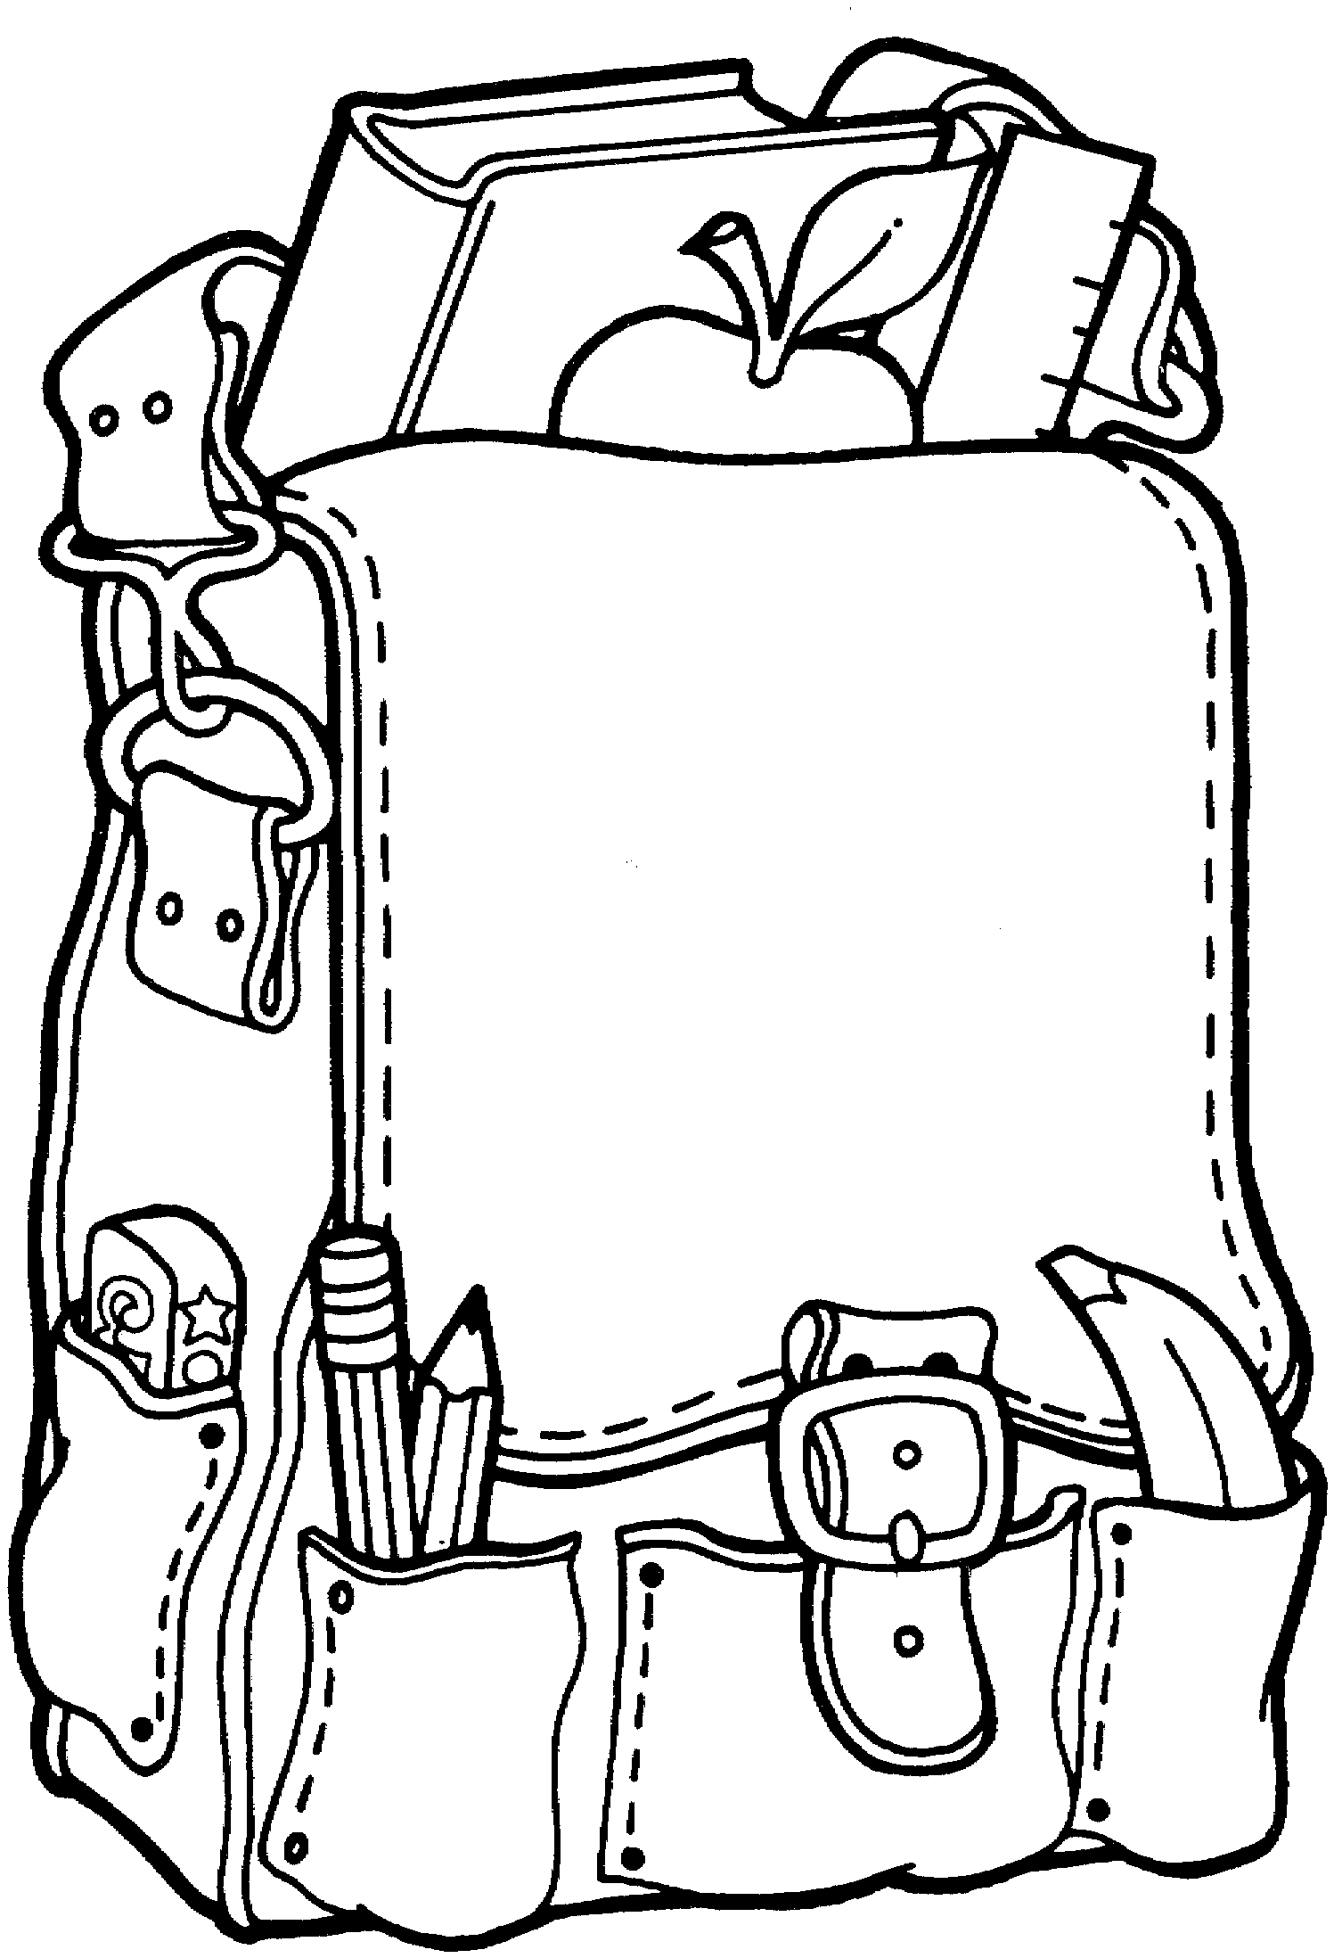C:\Program Files (x86)\Microsoft Office\MEDIA\CAGCAT10\j0185604.wmfC:\Program Files (x86)\Microsoft Office\MEDIA\CAGCAT10\j0185604.wmfC:\Program Files (x86)\Microsoft Office\MEDIA\CAGCAT10\j0185604.wmfC:\Program Files (x86)\Microsoft Office\MEDIA\CAGCAT10\j0185604.wmfC:\Program Files (x86)\Microsoft Office\MEDIA\CAGCAT10\j0185604.wmfC:\Program Files (x86)\Microsoft Office\MEDIA\CAGCAT10\j0185604.wmfC:\Program Files (x86)\Microsoft Office\MEDIA\CAGCAT10\j0185604.wmf