A late XIXth century advert for a cure for toothache.
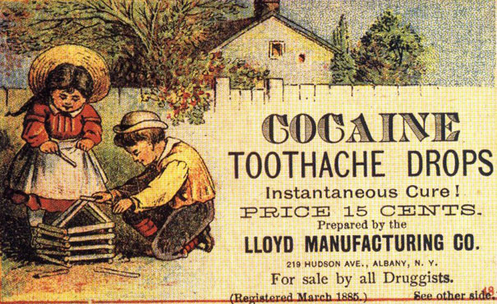
https://www.boredpanda.com/vintage-ads

Examples of Greenwashing
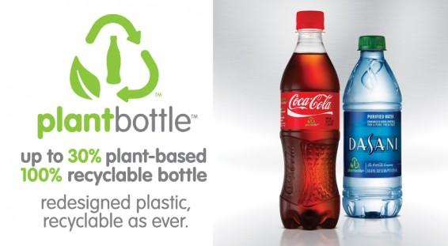
https://www.ibtimes.com

McDonalds’s « new » green logo.
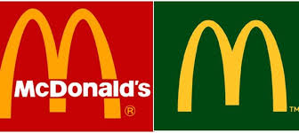
www.wemag.fr

McDonald's admits 1,000 people paid to join queue for Quarter Pounder debut in Osaka
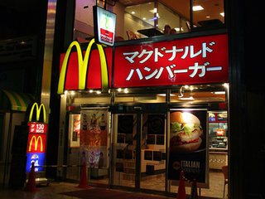
www.businessinsider.fr
Around 1,000 people were paid to join the queue outside the Midosuji-Suomachi branch of McDonald’s for the release of their Quarter Pounder burger in the Kansai area on Tuesday, it was learned on Thursday.
The company has admitted to the fact that around 1,000 people who lined up on Tuesday were compensated, but claims they only made a request for consumer feedback to one of their marketing companies. There are suspicions however that the people were employed to help promote the new product, serving a role known as "sakura" in Japanese.
It is estimated that as many as 2,000 people were lining up outside the McDonald’s store at its peak on Tuesday, and that around 15,000 people in total visited the store during the day, setting a new record for daily sales for one of their stores. But it was learned on Thursday that about 1,000 of the people queuing outside were paid an hourly wage of 1,000 yen and also had their purchase paid for. These people were hired by a human resources company at the request of a marketing company commissioned by McDonald’s Japan.
A McDonald's Japan spokesman said: “We wanted to know how the service and product quality were on the first day. We didn’t know 1,000 people had been sent to the store.”
www.japantoday.com

“The Coke Side of Life”—More Sugar, Less Science
Deborah Bailin, former analyst, center for Science & Democracy-August 14, 2015,
Almost 130 years ago, Coca-Cola first quenched Americans’ thirst and splashed its irresistible blend of sugar and, yes, cocaine, across our taste buds and brains. “Drink Coca-Cola and enjoy it” said the company’s first ad slogan. Since then, addiction and advertising have gone hand in hand to convince us that Coke is, as a 1985 ad spun it, “America’s real choice.”
But how does anyone really “choose” Coke? While the company removed cocaine from the product more than 100 years ago, the amount of sugar remains staggering. A 20 oz. bottle—just one serving according to its Nutrition Facts label—contains 65 grams of sugar. That’s about 16 teaspoons and far exceeds what the American Heart Association, the World Health Organization, and the U.S. Dietary Guidelines Advisory Committee all recommend that people consume in an entire day. Moreover, recent brain research has shown that sugar “can not only substitute to addictive drugs, like cocaine, but can even be more rewarding and attractive.”
All that science on sugar is important because it contradicts the message the company would like us to hear—that is, that we should “choose” to drink more of their product. Coca-Cola spends hundreds of millions of dollars on annual advertising to persuade us that its choice of what we should be drinking is “our” choice. But the company’s tactics to control consumer “choice” don’t stop with catchy ad slogans. Coca-Cola, like other sugar interests, also pours money into misinformation campaigns aimed at casting doubt on the growing body of scientific evidence showing that excessive sugar consumption is harmful to our health.
When we wrote about this phenomenon in (…) 2014 (…), we noted that many companies have their own research institutes and initiatives and pay scientific experts to conduct seemingly independent studies to promote their sugary products. We found that Coca-Cola’s Beverage Institute for Health and Wellness features misleading content on its website. The site confuses the science around sugar consumption and ill-health by focusing on the role of sugar-sweetened beverages in ‘hydration’ and ‘energy balance’ while ignoring the negative impacts of sugar-sweetened beverages, including their role in obesity and metabolic diseases.”
Just recently, the company established a new “research” institute called the Global Energy Balance Network. Its purpose is to persuade people that they’re focusing too much on calories and portion size and not enough on exercise. The Network claims to provide “a forum for scientists around the globe to come together and generate the knowledge and evidence-based pathways needed to end obesity.” But it doesn’t take much scratching under the surface to see that the scientists contributing to this forum can hardly claim to be independent of food industry conflicts of interest. At the top of their list of scientists is James O. Hill. A quick search of the Integrity in Science database, maintained by the Center for Science in the Public Interest, shows that Dr. Hill has ties to PepsiCo, McDonald’s, and the Sugar Association. He has also previously received consulting fees from Coca-Cola and other food companies.
Sure, “You can’t beat the feeling” of a Coke, as a 1987 ad put it. Why? It’s the sugar, of course! And, given what we now know is the toxic truth, Coca-Cola and other food companies have a lot at stake in persuading us to “choose” their sugary products over the science that tells us otherwise.
blog.ucsusa.org

