My chinese portrait
If i were a colour i would be purple because i like a purple and it’s my favorite colour and it’s cute and beautiful and i’am ambitious in life and it’s mixture from blue and red and a blue represents hope and a red represents loving.

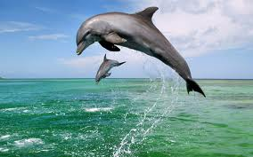

If i were a animal i would be dolpin because i’am quiet and king and helphul and i’am swimming with my familly and fiends and loving and tenderness.

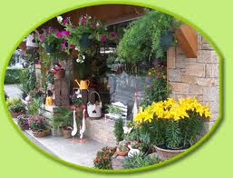

If i were a shop i would be florist’s shop because when coming a smell good flower’s and a flower’s nice and decorativeand so i as trade.

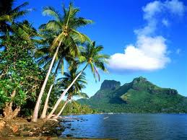

If i were a world i would be isle tropical because she is quiet and calm and beautiful and blue as hope and she making a dream and peaceful.

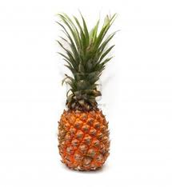
If i were a fruit i would be pineapple because he is in isles tropical and i love isles tropical and it’s my favorite fruit and he represents a sun.

