Correctrion du webquest sur l’esclavage:

Objectifs:

Faire ressortir le vocabulaire et les structures spécifiques

to have so do sthg

to make so do sthg….

le passif

remettre au clair les dates, les lieux

voir des exemples pour étayer les productions écrites

**Part I: Slavery in America**

1. Use the following link to answer the questions below- <http://www.pbs.org/wgbh/aia/part4/map4.html>
   1. By 1830, how many slaves were in the U.S.? What was their monetary worth?

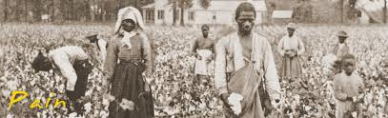More than 2Million slaves in the USA.

They were worth 1 Billion dollars.

b. What percentage of Southern whites owned slaves? 25 % of the Southern Whites owned slaves

**Go to** [**http://www.pbs.org/wnet/slavery/**](http://www.pbs.org/wnet/slavery/)

2. Click on “Time and Place.” Identify major events related to slavery in the following years:

* 1. 1619 beginning of the slave trade in the USA
  2. 1662 Hereditary slavery Act: a child born from a slave is a slave
  3. 1793the Southern production becomes more profitable. More slaves are bought.
  4. 1820 slavery is forbidden in Louisiana.
  5. 1831 violent rebellion in Southhampton. 7 white people are killed.
  6. 1850 California becomes a free state
  7. 1857 The Us supreme court denies citizenship to slaves
  8. 1865 slavery is forbidden

3. Use the following website and follow the directions listed:

* 1. <http://www.pbs.org/wgbh/aia/part4/4narr1.html>
     1. Scroll down and click on “weeping time.”

What was the Weeping Time? March 1859 Georgia 2 days 429 slaves from the same plantation were sold

* 1. Click back once to Antebellum. Scroll down and click on “Life Under Slavery.”
     + 1. How were slaves legally considered?

They were the owner’s property

* + - 1. How was this status legally enforced?

through violence

1. 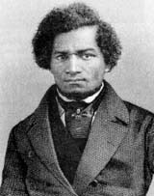Go to <http://www.pbs.org/wnet/slavery/>. On the pull-down menu on the right, select Religion.
   1. Who was Nat Turner?

he was born a slave

considered a prophet sent by God

* 1. What did he do? He planned a rebellion in the 1820s. 60 white men were killed. He died during the rebellion. He was executed.

1. Go to [http://www.pbs.org/wnet/slavery/experience/education/feature.html](http://www.pbs.org/wnet/slavery/experience/education/feature.html%20) And <http://www.history.org/history/teaching/enewsletter/february03/worksongs.cfm>
   1. What were songs used for?
   2. Songs were used to regulate the pace of their work on the fields, to talk about their masters and conditions, to keep the faith.
2. Hardships/Difficult Decisions of some slaves
   1. On the pull down menu click on Responses to enslavement. Choose slave decisions.
   2. **Cynthia’s** Decision- What factors contribute to Cynthia’s decision? What is your reaction to being faced with this dilemma?

she was a house slave. She lived with her master and they had children.

* 1. **Josiah Henson’s** dilemma- what makes his decision difficult? What decision does he make? Do you believe he regretted his decision?

He took revenge on his master.

He avenged the assault of his mother.

* 1. **John Mason**- What do you think of the decision John Mason made regarding his dilemma? was a slave who escaped to Canada. He went back to the South and helped slaves to break free.
  2. **William Grimes**- What does this dilemma suggest about the difficulty of relationships between slaves?

It highlights the fact that slaves were ready to have another slave beaten, or to do things , or to have anything done in order to improve their hardship.

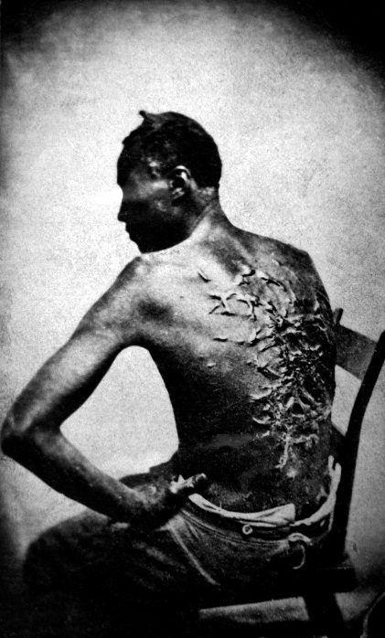**Part II: Slave Codes- Go to** [**http://www.pbs.org/wgbh/aia/part1/1p268.html**](http://www.pbs.org/wgbh/aia/part1/1p268.html)**.**

1. What were the punishments for a slave who broke the following rules?
   1. Murder- slaves found guilty of murder or rape would be hanged
   2. Robbery- for robbing or any other major offence, the slave would receive sixty lashes and be placed in stocks
   3. Associating with Whites- slaves would be whipped, branded, or maimed/mutilated
2. Go to <http://www.pbs.org/wgbh/aia/part1/1h308.html>
   1. What actions or behaviors would require a punishment with this device?

The slaves who were accused by their masters of insubordination (they refused to obey their master), or of eating more than they were allowed to eat, were fitted with an iron muzzle.

**Part III: Underground Railroad**

1. Go to <https://www.history.com/topics/black-history/underground-railroad>
   1. What was the Underground Railroad?

a network of African American and white people who offered shelter and aid to the runaway slaves

There were many well-used routes stretching west through Ohio to Indiana and Iowa. Others headed north through Pennsylvania and into New England or through Detroit on their way to Canada.

* 1. What was a conductor: a guide 🡪s.o. who is guiding s.o. to…
  2. What is a safe house? How did you know it was a safe place?

a safe house was a location where slaves could safely find protection and food.

* 1. Identify individuals who might assist you on the Underground Railroad.

The slaves had to trust the conductor.

Reverend Calvin Fairbank, John Brown, Harriet Tubman…

People known as “conductors” guided the fugitive slaves. Hiding places included private homes, churches and schoolhouses. These were called “stations,” “safe houses,” and “depots.” The people operating them were called “stationmasters.”

* 1. What were the hazards you encountered on your journey?

The Fugitive Slave Act passed in 1793, allowed local governments to apprehend and send escaped slaves back to their point of origin, and to punish anyone helping the fugitives.