Shard attack

It all happened on the afternoon of 11 september 2021 – 20 years day for day after the NYC attacks on the Twin Towers.
The world was torn between fundamental Islamists & true-blue capitalists.
London City was – more than ever – the Babylon of wild speculation, laying down people all over the world as well as some unfortunate traders, a very restricted number compared to the millions of whom they had caused the loss of their jobs & starvation because of their bets on the ups & downs of the Stock Exchange auctions.
I was – as usual – doing my job for MCQ (“Maintenance Company of Qatar”- at the Shard, built at the very same place where the Southwark Buildings used to stand, in the heart core of the city where I was born.
My name is Kevin Mac Carthy. I’ve got Irish ancestry (my parents were born in the Emerald Isle). I like having a pint - or a few more - in this district which I have elected as my recreation place. I love the ambiance there, especially at the weekends in the summertime when we drink pints with my workmates at “The Old Tavern” (supposed to date back from Shakespeare’s times) & observing the life & the tourists having fun along the pedestrian right bank of River Thames (the southern bank).
The job is well-paid – my business is owned by Qatar’s Prime Minister Hamad bin Hassim bin Jaber al Thani who also owns a race-horses stable. No worries for my working mates & myself: 2 of his best yearlings won the Epsom Derby & Ascot. We had bet on the horsies (Ozo – like the Tower - & Shard)
This part of London Town is called “Southwark” (the south ark of river Thames). It makes me laugh when I hear the visitors to our good old city try to pronounce it. It all ends up in something like “souswark” as they can’t pronounce the ”th“ sound properly (though they used to pronounce it without difficulties when they were 1 or 2 years old (what faculties do human beings lose from birth to death!). What we like – me & my friends - is when a French tourist orders a “smoozie”. It’s so funny to see Peter, the landlord pretending not to understand & winking at us!
That’s the moment for us to intervene & help these poor lost girls against “bad Peter” & try to explain to him what the girls want though he pretends not to understand a bloody word!
I’ve got a friend who organizes tours of London. He never misses my favourite pub & we finish the tour of Old Shakespearean London with him & the girls we meet in the City soul pubs –open until 3:00 am on Sunday mornings.
That’s a good life & I don’t intend to get married. I like sauntering after work in this touristic district & have contacts – especially with French girls. The French are so funny! They never realize how stupid they are – though they keep on thinking they’re the best in the world! What great fun to pretend to admire them! They feel like they are on a rainbow whereas we are just kidding them!

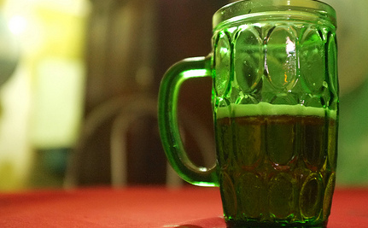

I’m in charge of the maintenance of various prestigious buildings such as Harrod’s, Selfridges, the Emirates Stadium & - since 2012 – “the Shard”. At the beginning, I was just a plumber who qualified as a fireworker & life-saver. That’s how I got a job for the plumbery infrastructure when they started to build the Olympic Stadium at Stratford (East-London) in 2009. I already was the owner of the company created by my father.
I followed “life-recovery training”. Once I saw an advert in the cafeteria of the company I was working for before inheriting from my father’s & decided to follow that survival-based course with my 4 pals. I’ve employed them for about 4 years. They all come from Poland as the economic situation is critical in that country. They all have big families to provide for & I’m a little proud of myself to be able to help these unfortunate people. Anyway, they’re the best workers in the world & could accept any conditions (they have no choice poor fellows!)

To make a short story long, I was there, at the top of the Shard (the 2nd highest high-rise tower in Europe topping at 1,012 ft – 308.5 meters). I had been called for an emergency at the 72nd floor of the 87- storeyed shark-tooth looking spire - (not very far from “the Girkin” & close to London Tower - surpassing Ozo Tower by almost 3 dimensions). A plumber’s job often implies coping with gunk & clogging in the waterpipes & - you know what I mean: you have to dirty your hands - “Where there’s muck there’s money” as the Jocks say. I was there, commanding my team of Polish employees when I heard a growing buzzing sound, like the one of an airborne-fusileers army plane (I fought in the Falklands War in 1984). To my utmost surprise, that Jumbo-jet collided “The Shard” at the level of the “Shangri -La Hotel” (around 200 meters above ground level)
“How could this plane have been allowed to fly so low over the City of London?” That was the first question I asked myself. I immediately phoned my Polish foreman who had been called to the 62nd storey where all the damage seemed to come from. He answered me back on his mobile - in his Eastern-European tinged English - that it was like in 2001 in NYC. That’s when I started to realize.
From above, I saw the jumbo jet’s left wing literally detach itself from the main part of the aircraft & get down in flames after colliding into “the Shard”. It crashed into Park Street, causing a crater in the tarmac as the left-wing engine was ablaze. The shell of the aircraft finished its course into the Millenium Bridge & caught on fire (poor dooming Millenium Bridge!)
Though being from Irish ancestry & reputed for having a reckless temper, I must admit I wasn’t self-assured. I was shaking & sweating all over. What a silly end of life burning dead at the top of a tower! I’m only 41! What an unhappy ending such as my cousin’s in the charred remnants of the Twin Towers (that’s when I realized what the date was & I got even more panic-stricken (Irish people are very emotional).
I was stunned for about 5 mn. Surprisingly, nothing happened apart from a to & fro sway which was tending to become unbearable at the end. Then, the whole structure started to get steadier. Only a few waverings & creaks & everything was over. I remember shouting to the kerosene smoke-dimmed City lofts of London : “ God bless you Irvine Sellar & Renzo Piano (the architect & conceptor of The Shard). This time isn’t like 20 years ago & we won’t let ourselves do …May St Patrick bless you!”
Then, my mobile buzzed. It was 10:13 am. I checked Piotr’s (my Polish foreman) ID on the screen. His text ran like this:”I need you at 62nd (that’s the floor he had been called for the same problem as mine: pipe-clogging) I got a lot of problems with the tourists & residents as they can’t use the lift”
Piotr knew I was qualified at life-saving & abseiling. He was good too; for I had taken him to Chamonix for a rock-climbing holiday in February 2018.
I texted him back : “Don’t worry pal! We’re gonna make it! We’re the only responsible people in this tower; they’re all sharks – or sharkies – of finance. Just remember our one-week stint in Chamo! –we’re gonna rescue all those little long-toothed fishes & draw the benefits from it!”

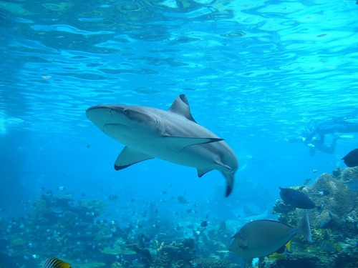

After 2 mn, the police were there: first under “The Shard” with police cars & ambulances, then above the building with helicopters. The building had stopped swaying. Only a few creaks that could make you fear the worst. I was agonizing!...

I could see a big white helicopter looming over the Shard. As soon as I was in view, I started waving at them – but they were rather seeing the other people waving from the “Shangri La Hotel” though I was wearing my yellow fluo vest
The police must have received desperate calls from those jet-set people.
That’s when I had the idea of calling my team of plumbers to use the stairs & get those jet-setters to use the emergency staircase & ascend the 10 floors so as to get right up where I was. I was planning to take them to the tip of the tooth whose key (a magnetic card) I always had in my pocket & hoist them by means of ropes which I knew were there in a locker in case of emergency such as this one into the helicopter(s). Piotr texted me that my team of workers was allright. The problem was all those panic-stricken people – some of them half naked women, who had never thought of such an experience in their lives & a few elderlies . They were quite hectic & I understood Piotr was in a bad patch. I could picture him – a father of 5 – in the hoipoloi of those half-naked ladies & couldn’t refrain a smile at the thought o it. But such wasn’t the time to wonder about those things!
“Don’t worry mate! Calm down your fans! You’re not alone with Dmitri, Andrei & Igor, you should cope with all those demon-lovers( lol) Take the emergency stairs while I’m unlocking the abseil ropes locker! We’re gonna hoist all this little folk into the police helicos!”
When they saw all those people starting to arrive on the platform of the Shard the policemen started using the loudspeakers & give us instructions. Piotr & meself started to harness the first victims to a hook thrown from the helicopter. My squad was in charge with guiding all those people to the 72nd floor platform. They had a rough time poor guys for they had to carry in their arms swooning ladies, even handicapped people. But I know they don’t regret it by now. Surprisingly, we didn’t meet any member of the hotel staff…
We evacuated exactly 97 residents of the Shangri-la Hotel, some of them in wheelchairs which we fastened as best as we could with Piotr, under police-helicopter guidance. It lasted until nightfall. At the end of the day, there was a constant ballet of droning helicos above River Thames. Then it was our turn to be hoisted. We were so exhausted that we could hardly speak. My team had received phone calls from their anxious families but had had no time to answer back.
Then we were taken to the airborne police headquarters & they started congratulating us & telling us that we were true British subjects worthy of the respect of King Charles III. The superintendent made a speech & declared he would command us for the Victoria Cross.
All we were eager to know – me & my team – was what had really happened. At that point, they couldn’t tell us: it was a state secret. The Home Ministry was unwilling to reveal anything… even to us…
They drove us back home. First to Piotr’s whose wife & 5 children were agonizing, then to Igor’s whose 4-members progeny jumped at our necks, then to Andrejz’s who wanted to invite me for dinner – which I declined for I was frazzled. When we got to Dmitri’s (only 2 children), the youngest of my team & living closest to my home (Wanstead), I was fast asleep & snoring like a Lord for we had drunk at least 4 or 5 whiskies (not baby whiskies). But we needed it after such a hard day.

On the day after, I had to wake up very early (as usual). My body was aching all over. But life goes on! I phone my gang & they were all ready to follow me despite the ordeals they had had to undergo. I gave them until 2:00 pm to recover for we had to fix a problem at the Arsenal Emirate Stadium.
“Don’t worry pals” I texted them “we’re soon gonna be ennobled by our Gracious King”
They all sent back dubious messages (for they are foreigners trying to make their way in the UK & be recognized as British subjects).

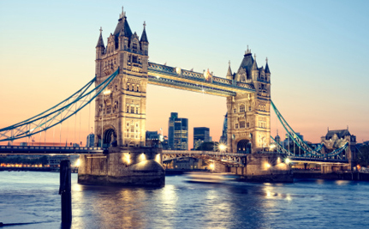
Today is 11th september 2012. We’ve just been awarded – my gang of plumbers & meself – the Victoria Cross. Those foreign-born heroes can’t believe their good fortune & would be ready to follow me anywhere on earth. In addition, they have made a few shows on TV & are becoming very popular. Some TV channels have proposed to them to write a scenario of their ordeal at the Shard. Dmitri, the youngest of my gang, has already shot in a film. He’s posed as a model in a “fireworkers’ calendar” for this year. I think he’s on a good path (he’s only 22). We could see him starring in a film one of these days!
As for meself, I’ve bought an apartment at the Shard with the money granted to me for “heroic feats”. I know I could cope in case of emergency. I did a few interviews for BBC, CNSBC, Fox News… & many others…
What a good life we have there in London. Now, I living right there I wanted to live & I don’t have to commute from Forest Hill to Central London. It took me 45 mn by tube!

To conclude a long story short, there was no Al Qaida attack on the Shard on 11th September 2021. What happened is that a squadron of airborne fusileers was sent for a mission over London City (as – I may guess- over every important city in the US & other cities all around the world). We’ve got a syndrome since 911! The left wing engine got on fire while they were over the Shard. The unexperimented RAF pilot couldn’t cope with the situation as they were only 3 staff on board. As a result, 3 charred corpses belonging to His Majesty’s troopers were found back at the foot of the Shard (official communiqué from “The times”).

I go on betting on my favourite sheik’s horsies – as well as my gang of Polish plumbers – I think we’re gonna hit the jackpot one day! It’s all right with me: I live in the world’s hub where all the financial decisions are taken. We have a multiracial population who can make it here.

I invite you to settle in London.

What a great city!

Kevin Mac Carthy

