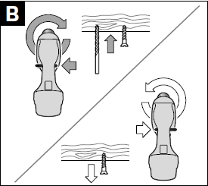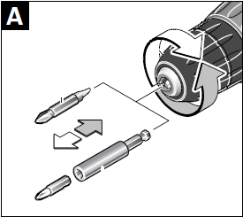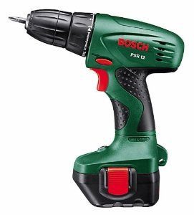

Drill bit

light

**A** Turn the keyless chuck to loosen drill bit and change the drill bit than tighten strong .

B Press the switch to change the rotation.

D Remove the batteries and plug in on sector for reload.

We fixing the batteries thanks unlocking button

C Press the push-button to drill or screw and unscrew. According to the force exerted by your finger on the push-button we have different speed of rotation.

When you use it the light on.

Keyless chuck

switch

battery

push-button

**Wireless drill – Screwer PSR 12**