Spaces and Exchanges
Introduction :
The aspects of the notion of Exchanges, which I will focus on, can be cultural, demographic, geographic or economic.
I will be concentrating on how, in our modern-day consumer economy, advertising, greenwashing, astroturfing and lobbying have become unavoidable.
The angle I have chosen can be illustrated by this question :
When we consider consuming or governing, when does helping turn into influencing, and when does influencing becomes manipulating?
Part 1 : generalities.
In a democracy, the government have to make up their minds on any and every subject. The parliament or any other legislative body, have to vote laws which will apply to every aspect of a modern society.
However, nobody knows everything on anything.
This also applies to all of us, private individuals. We have to make up our minds on choices we make when we buy our food, our home appliances, our cars, and so on.
That’s why decision makers or simple citizens have to seek information, counsel and advice from experts who will give detailed and expert insight in the field in question.
We will look into the problems which may arise then.
- When can we trust the information we are given on products?
- When does expert advice becomes dishonest lobbying?
- When does private interest try to influence and profit from public interest?
Part 2 : advertising and greenwashing.
The consumer society has, from its beginnings, always made extensive use of advertising. This is probably the most obvious example of influencing consumers.
As you can see on this amazing ad promoting cocaine drops against toothache at the end of the XIXth century, the strangest products were being advertised! These drops are among the ancestors of Coca Cola.
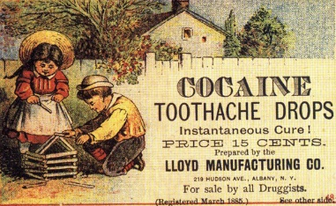
Nowadays, new advertising trends have appeared, such as greenwashing.
It is a term ( inspired by the word “whitewashing” ) given to a marketing approach that deceptively pretends a product to be environmentally friendly despite offering limited or no environmental benefits.
With the growing demand by consumers for a sustainable economy respectful of natural resources and good for the body, major food companies turn to greenwashing.
This document shows the so called “Plant bottles” which were introduced by Coca Cola in the 1990’s.
Plant Bottle differ from traditional plastic packaging in that it uses plant-based material instead of petroleum and other fossil fuels to produce monoethylene glycol, a key ingredient in PET (polyethylene terephthalate) plastic
The Danish environmental group Forests of the World (accused) Coca-Cola of greenwashing. The group blasted PlantBottle posters and ads featuring environmentally friendly imagery (leaves, green fields, farms, wind turbines, butterflies and flowers) and said that Coca-Cola simply had no proof that its product offers any positive effect in reducing CO2 emissions.
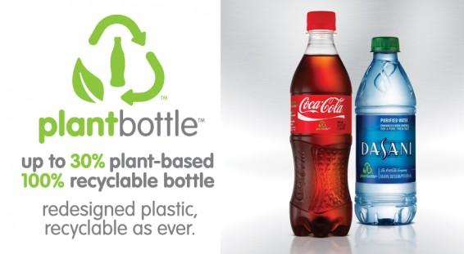
We can also mention the new green signs McDonald’s introduced a few years ago for their European restaurants.
As you can see here, the new logo has a green background in in order to emphasize the company’s new efforts towards more environment friendly products and recycling.
This strategy is essentially the textbook definition of greenwashing: Promoting green in the abstract, literally re-painting your signage with the color green, while simultaneously making sparse, vague claims about environmental action.
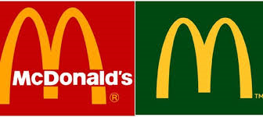
With these previous examples, we can see how consumers are the target of misleading actions meant to alter the truth or even create fake data in order to manipulate them.
Part 3 : astroturfing.
As we have just seen, influencing consumers can lead to manipulating and misleading them.
Another example of such fake info can be found in astroturfing.
This word first appeared in the mid 80’s and comes from a synthetic substitute for grass known as AstroTurf. It is a wordplay on grassroots which can be defined as the organized effort of people who are not part of an elite to achieve a common goal.
Astroturfing is the creation of a fake grassroots organization to pretend there is popular support for an industry, firm or political party. Such organizations may have deceptive names with terms such as "citizens for ...", "committee" and "project." It is also common for the name of the organization to contradict its goals. For example, an organization that lobbies for reduced environmental regulations may adopt a greenwashed name.
An astroturfed organization may have few actual members and simply act as a front for lobbying, political donations, promotion and advertising.
A perfect example of astroturfing can be seen in this document.
The release by McDonald’s of a new hamburger, the Quarter Pounder, in Japan attracted a record big crowd in Osaka
As it turns out, McDonalds had recruited 1,000 part-time employees to line up at midnight, before the store even opened. It generated buzz for the burger. The "customers" were paid for their time and had a free meal. McDonalds admitted the cheating, but said it was part of a "customer feedback" for "market research."
The employees were paid roughly $11 an hour for their work.
McDonald's admits 1,000 people paid to join queue for Quarter Pounder debut in Osaka
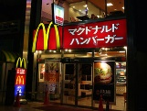
Around 1,000 people were paid to join the queue outside the Midosuji-Suomachi branch of McDonald’s for the release of their Quarter Pounder burger in the Kansai area on Tuesday, it was learned on Thursday.
The company has admitted to the fact that around 1,000 people who lined up on Tuesday were compensated, but claims they only made a request for consumer feedback to one of their marketing companies. There are suspicions however that the people were employed to help promote the new product, serving a role known as "sakura" in Japanese.
It is estimated that as many as 2,000 people were lining up outside the McDonald’s store at its peak on Tuesday, and that around 15,000 people in total visited the store during the day, setting a new record for daily sales for one of their stores. But it was learned on Thursday that about 1,000 of the people queuing outside were paid an hourly wage of 1,000 yen and also had their purchase paid for. These people were hired by a human resources company at the request of a marketing company commissioned by McDonald’s Japan.
A McDonald's Japan spokesman said: “We wanted to know how the service and product quality were on the first day. We didn’t know 1,000 people had been sent to the store.”
www.japantoday.com

Part 4 : lobbying.
I will finally speak to you today about what is probably the best known, and also probably the most effective, means for companies and other private interests to influence – and maybe manipulate - decision makers ; that is, lobbying.
If you lobby someone such as a member of a government or a council, you try to persuade them that a particular law should be voted or changed, or that a particular thing should be done
Of course, we are leaving here the field of trade and the economy to look into the way decision makers can also be influenced, if not manipulated.
In the following document, we have seen how such major companies as Coca Cola can mislead the general public and, as a consequence, law makers. The company has created the Beverage Institute for Health and Wellness which seems to be a non-profit science organization.
As we can read in the document, it was “found that Coca-Cola’s Beverage Institute for Health and Wellness features misleading content on its website. The site confuses the science around sugar consumption and ill-health by focusing on the role of sugar-sweetened beverages in ‘hydration’ and ‘energy balance’ while ignoring the negative impacts of sugar-sweetened beverages, including their role in obesity and metabolic diseases.”
With this, Coca Cola tries to cover up how dangerous the sugar contained in its beverage can be for the consumers who have made “the choice” to drink them.
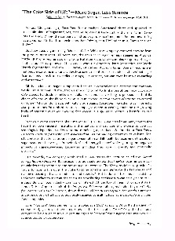
There are, of course, hundreds of other examples of lobbies using partial or fake information in order to improve their businesses.
Conclusion :
As we have seen, there are many ways in which private interests can influence or even manipulate us to their advantage. Whether it be advertising, greenwashing, astroturfing or lobbying, it has become extraordinarily difficult to be aware of them.
This is probably why we have so often checked for customers’ reviews and independent reviews on the Internet.
But can we always be certain that they were really written by those who pretend to have written them ?

