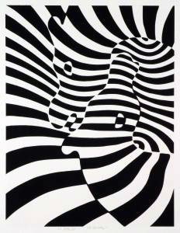

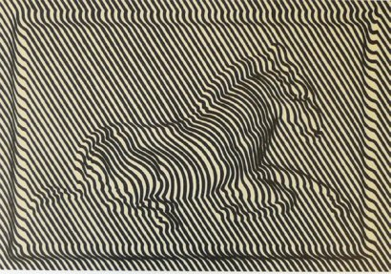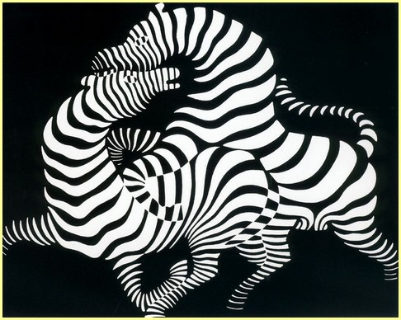  
  
  
  
  
  
  
  
  
  
  
  
  
  
  
  
  
  
  
  
  
  
  
  
  
  
  
  
  
  
  
  
  
  
  
  
  
  
  
  
  
  
  
  
  
**Victor VASARELY**