Quiz n°2
Full name :…………………………... Date:…………………………..
Class :……………
Number :………….

Task I: Complete the following dialogues(3pts)
Tina: ………………..…a student?
Jim: Yes, I am.
Tina: ………………………….….……?
Jim: I am in class 5.
Tina: ………………………………….….?
Jim: My favourite school subject is maths;……………..………………….?
Tina: My favourite school subject is English

Jimmy: Hi! My name is Jimmy.
Lina: Hello! I am Lina.
Jimmy: ………………….……. …..?
Jimmy: No, I am Australian.
Tom: ………….………………...….?
Lina: I am from Sydney.

Task II : Match the following questions with the answers

1-Is Ahlam a student? F-No, I am not.
2-Are you English teachers? b- Yes, they are.
3-Am I Scottish? c-No, we are not.
4-Is Mohamed Moroccan? d- Yes, she is.
5-Are you a doctor? e-No, you are not.
6-Are Sanae and Ilham Australian? a- Yes, he is.
.

Task III: Write the name of the school subject
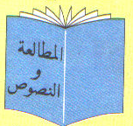

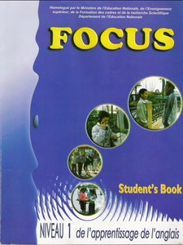


1-……………. 2-…………….. 3-………………. 4-..……………

Task IV: Write the names of the following school objects


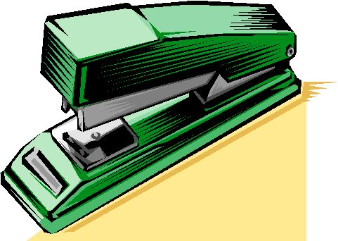


1-……………. 2-……………… 3-………………… 4-……….………….

