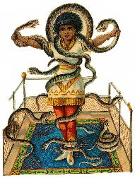 | PART – I: Describe the person using the information given.  Name: Luana Snake  Age: 17  Country: India  Phone number: 00 334 379 561  Marital status: single  Occupation: actress  Languages: Hindi, French, English  Sports: Volley  Favourite food: Fruit, bread  Car: (no car – a bicycle)  Music: Classical music, New Age  Abilities: Sing, dance, juggle, cook
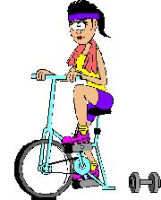 | PART – II: Describe the person using the information given.  Name: Maria Bloom  Age: 23  Country: England  Phone number: 00 334 379 561  Marital status: married  Occupation: student  Languages: French, English  Learn English: Studies, Travel  Sports: Volley, Gymnastics  Favourite food: Fruit, bread  Car: (no car- a motorcycle)  Music: Rock and Roll  Abilities: Play the violin, dance

