Food Fruits

  apple | 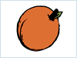  apricot |   avocado |   banana
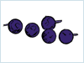  blueberries |   cherries | 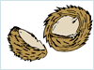  coconut | 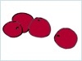  cranberries
  fig |   grapefruit | 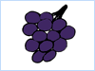  grapes |   honeydew
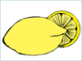  lemon | 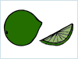  lime |   nectarine | 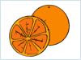  orange
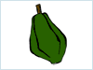  papaya |   peach | 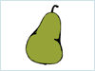  pear | 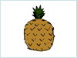  pineapple
  plum |   prunes |   raisins |   raspberries
  strawberries | 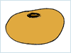  tangerine |   watermelon

