To Be: Positive or Negative Gap Fill

In this exercise, choose the correct form of the verb 'to be' to go into each sentence. It could be positive or negative.
Use contractions where possible.

Haut du formulaire
1. My teacher's name .......…..Melanie. She is English.
2. I …………..married. My wife is called Afaf.
3. My favourite colour ………..……blue. It's red.
4. My favourite sports ……..tennis and surfing. I play tennis every Saturday.
5. My best friend ………….a student. He is a policeman.
6. Peru ………….in Asia.
7. …………….you from Britain?
8. ……………..Sean Connery from Scotland? Yes, he is.
9. How old ……………your sisters?
10. My brother …………very happy today because it is his birthday.
11. Hassan II mosque ……………in Rabat. It is in Casablanca.
12. ……………Moroccan? Yes, I’m Moroccan.
13. They…………….Christians. They are Muslims.
Continous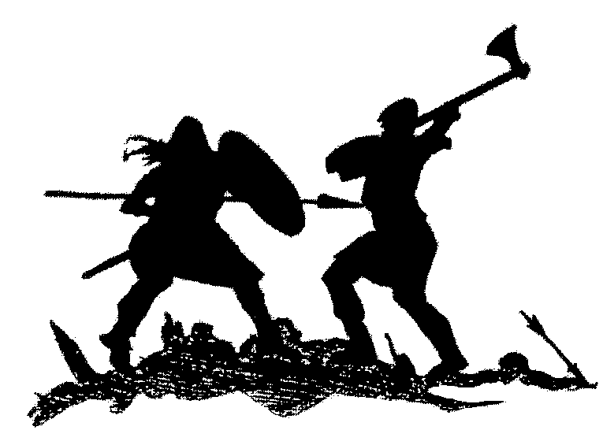fight
Is notis not is not
Is
Are

Are not Bas du formulaire

