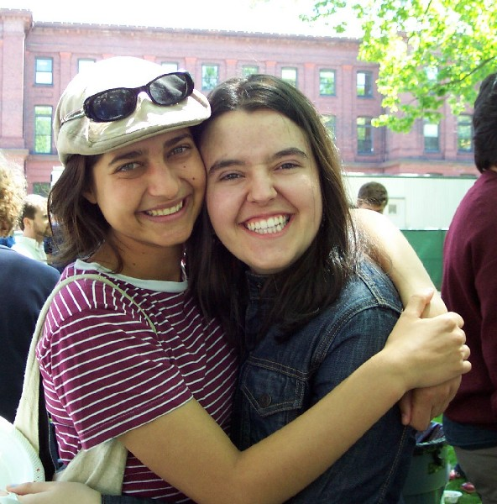
My personal information

I’m Hanaa Zahia and I am Moroccan. This is photo of me and Ibtisasam. She is a Student in Mouaad bnou Jabal

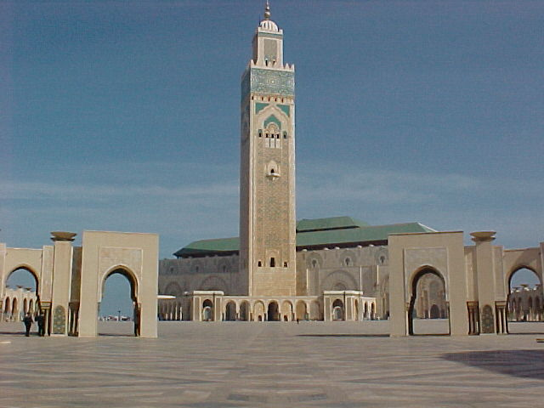
I am from Casablanca. It is a beautiful city. It is my favourite city in Morocco

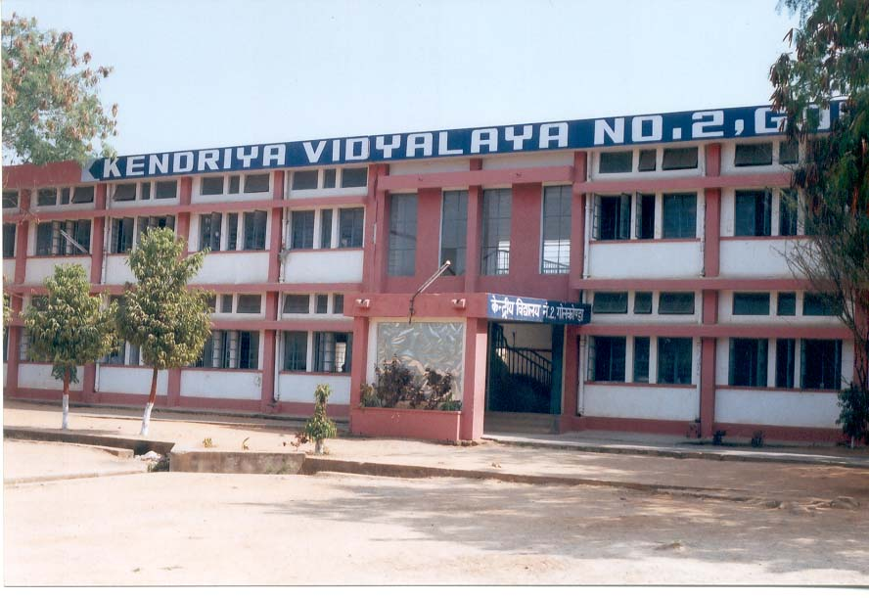
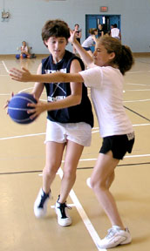
I am a student in Class 4 at a junior school. My English teacher is Moroccan. He is from Fez. My favourite school subject is Maths.
This is a photo in the playground of my school. My favourite sport is volleyball.

