House

Housing, Furniture, Tools & Toys Rooms of The House

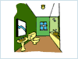  bathroom | 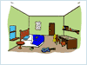  bedroom | 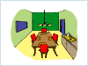  dining-room | 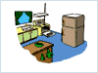  kitchen
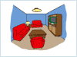 | Living-room

Housing, Furniture, Tools & Toys In the Living Room

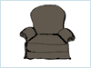  armchair | 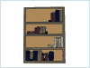  bookshelf | 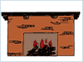  fireplace | 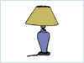  lamp
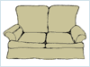  loveseat | 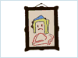  painting | 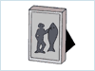  picture | 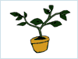  plant
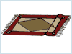  rug | 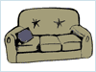  sofa | 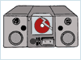  stereo | 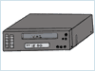  VCR
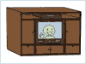  wall unit | 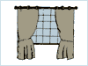  window

Housing, Furniture, Tools & Toys In the Kitchen

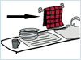  dish towel | 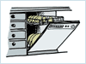  dishwasher | 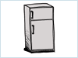  fridge | 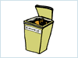  garbage can
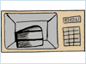  microwave | 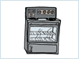  oven | 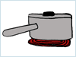  pot | 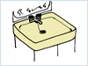  sink
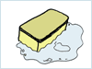  sponge | 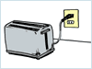  toaster

Housing, Furniture, Tools & Toys In the Dining Room

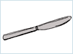  butter knife | 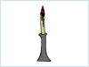  candle | 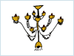  chandelier | 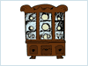  china cabinet
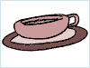  cup | 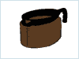  decanter | 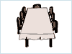  dining room table | 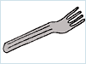  fork
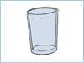  glass | 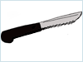  knife | 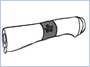  napkin | 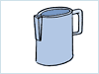  pitcher
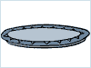  plate | 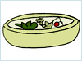  salad bowl | 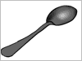  spoon | 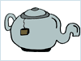  teapot
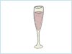
wine glass

Housing, Furniture, Tools & Toys In the Bedroom

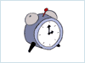  alarm clock | 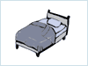  bed | 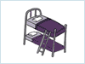  bunk bed | 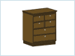  drawers
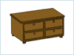  dresser | 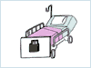  hospital bed | 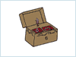  jewelry box | 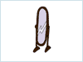  mirror
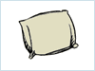 | pillow

Housing, Furniture, Tools & Toys In the Bathroom

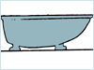  bath | 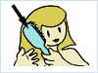  brush | 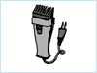  electric razor | 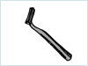  razor
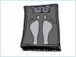  scale | 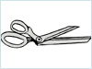  scissors | 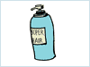  shampoo | 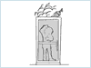  shower
sink | 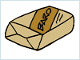  soap | 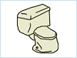  toilet | 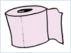  toilet paper
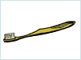  toothbrush | 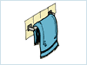  towel

