Exercise
First Term
Global Review
- Vocabulary 1
  - Name the pictures

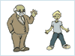
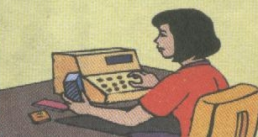
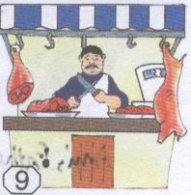

Ugly teacher teacher old
Happy old secretary pilot
Big new fisherman butcher
- Grammar
- Complete the table.

Singular | Plural
a teacher.  …………………………………………………….  a rubbish bin  ……………………………………………………  a book | …………………………………………………  Engineers.  …………………………………………………..  Envelopes  ……………………………………………………

  - Language.

    - Write is / are
- Complete with a / an / ø.
- I am student.
- Ali and Kamal are students.
- He’s engineer.
- Those are books.
- Ali a student.
- I andAli students.
- That a book.
- He an engineer.
- Those teachers.

    - Complete with the correct pronouns. I/he’s/she’s/It’s/they’re.

- . Samir is a my friend. a student.
- am Sanae.
- I am from Tangier. a big and lovely city.
- Amina is Moroccan. a teacher.
- Ali and Sanae are my brothers. engineers.

  - Complete.

- ? Yes, . Ali and Kamal are brothers.
- ? No, , . I and Jim aren’t Moroccan.
- ? Yes, . Micheal Jackson is a singer.
- ? No, . Fatima isn’t a sportswoman.

  - Write there isn’t / there’s or there aren’t / there are.
- a park in Tangier.
- a canteen in my school.
- Big classes in my school.
- a grocery store in my school.

- Write the correct possessive pronouns. My/your/his/her/its/our/their.
  - I’m a student. name’s Karim.
  - He is my brother. hobby is palying bascketball.
  - She’s my sister. friend is Sanae.
  - It’s a nice car. name is Mercedes.
  - We are students. city is Tangier.
  - They are brothers. names are Kamal and Nabil.

  - Write the correct form of the verbs.
- I (play) football.
- Ali (play) tennis in the park.
- They (play) basketball in the morning.
- We (play) handball in the playground.

  - Write the correct form of the verb.
      - I (play) football.
      - He (study) Maths and English in American school.
      - She (listen) to music.
      - They (work) in a hospital.

  - Vocabulary 2
- Complete with the verbs: play, live, do shopping, study, work, listen.

Hi!

I’m Amine. I in Tangier, Morocco. It’s a big and beautiful city. I’m a student. I in American school.

My father’s name is Selam. He in a bank. My mother’s name is Fatima. She in a hospital. My mother and father usually in Marjane. I have one sister. Her name is Sara. She classic music. My brother is a sportsman. He basketball and football.

        - Use genitive ‘s.

The name of my brother is Jim. .
The favourite school subject of Ali is Maths. .
This the school bag of Khalid. .

  - Complete with whose / who.
- ? It’s Najat’s.
- this? he’s my brother.
- notebooks are these? They are Kamal’s.

