HALLOWEEN

Halloween is a holiday celebrated in the night of October 31st

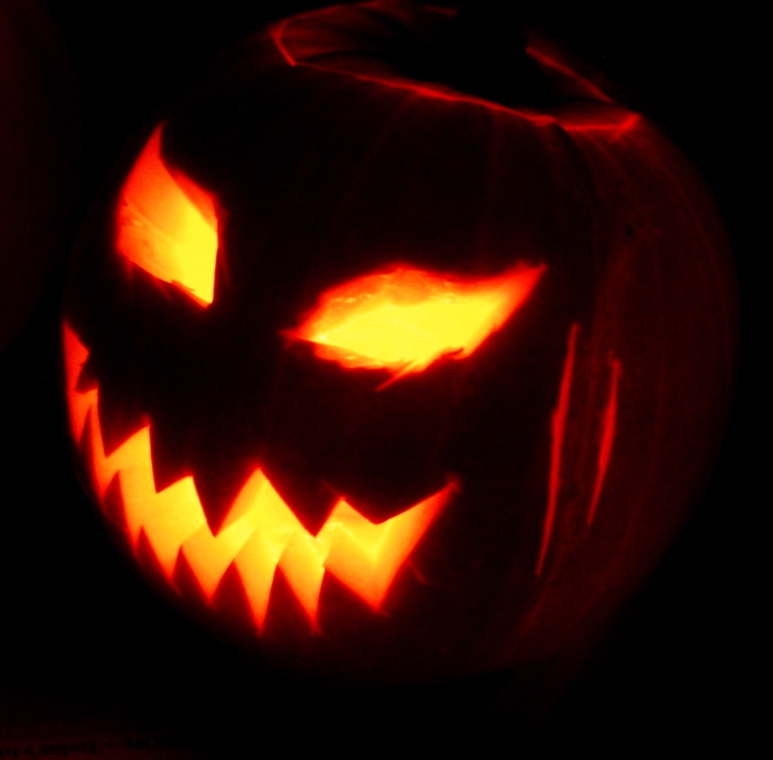

1/ Halloween activities

Halloween activities include trick-or-treating (Children say "Trick or treat!" to ask for candy), costume parties, visiting “haunted houses”, carving Jack-o'-lanterns, reading scary stories and watching horror movies.

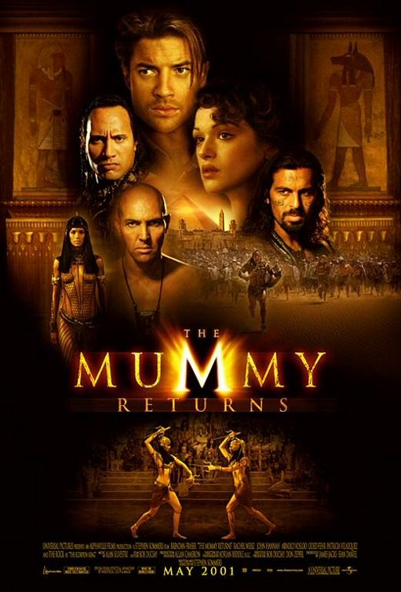

2/ Symbols

The carved pumpkin, lit by a candle inside, is one of Halloween's most prominent symbols in America, and is commonly called a Jack-o'-lantern.
Halloween imagery tends to involve death, magic, or mythical monsters. Traditional characters include ghosts, gouls, witches, owls, crows, vultures, pumpkin-men, black cats, spiders, goblins, zombies, mummies, skeletons, and demons.
Particularly in America, symbolism is inspired by classic horror films, which contain fictional figures like Frankenstein's monster and The Mummy. Elements of the Autumn season, such as pumpkins and scarecrows, are also prevalent. Homes are often decorated with these types of symbols around Halloween.
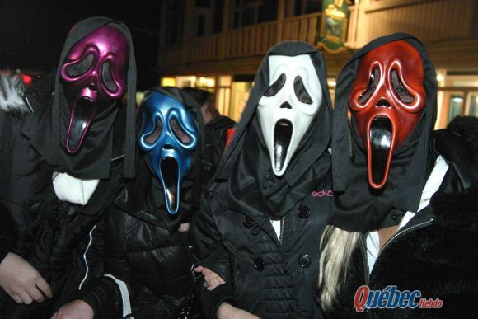

3/ Halloween history

Irish immigrants carried versions of the tradition to North America in the nineteenth century. The ancient Gaels believed that on October 31st, now known as Halloween, the boundary between the alive and the deceased dissolved, and the dead became dangerous for the living by causing problems such as sickness.

4/ Halloween around the world

Other Western countries embraced the holiday in the late twentieth century. Halloween is celebrated in several countries of the Western world, most commonly in the United States, Canada, Ireland, Puerto Rico, Japan, New Zealand, United Kingdom and France.

By Aude, Emilie, Imane, Sophyan – Seconde 15.

